 |  | Autumn 1 | Autumn 2 | Spring 1 | Spring 2 | Summer 1 | Summer 2
Topics | History  Geography  Science | Stone Age Britain  Bronze Age  Rocks | Countries of the world  Animals including humans | Bronze Age Britain  Iron Age Britain  Forces and Magnets | Rivers and mountains  Forces and Magnets | Romans  Plants | A journey to Italy  Light
Whole Class Reading Texts |  | George’s Marvellous Medicine  - Roald Dahl  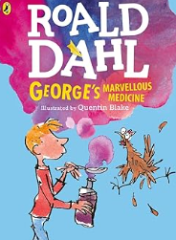 | The Hodgeheg  - Dick King-Smith  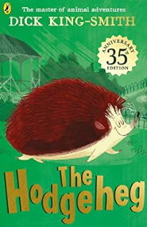 | The Iron Man  - Ted Hughes  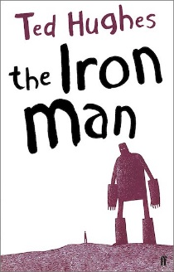 | The Hundred Mile an hor Dog-Jeremy Strong  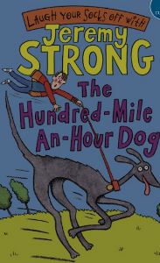  Forces and Magnets  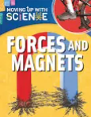 | Heard it on the Playground- Alan Ahlberg  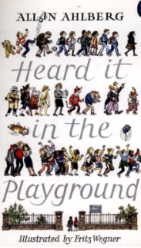  The Land of Roar  - Jenny McLachlan  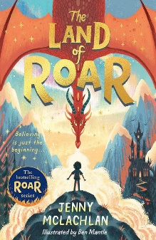 | The Diary of a Killer Cat  - Anne Fine  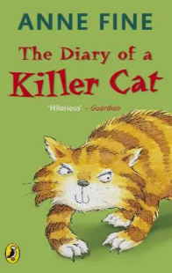
Reading for Pleasure |  | The Twits  - Roald Dahl  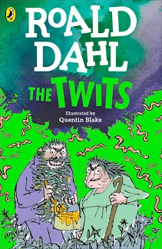 | The Mouse Family Robinson  - Dick King-Smith  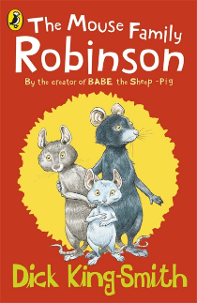 | The Iron Woman  - Ted Hughes  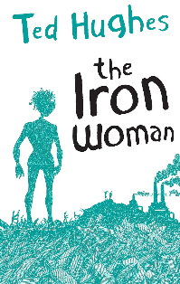 | The Secret Seven  - Enid Blyton  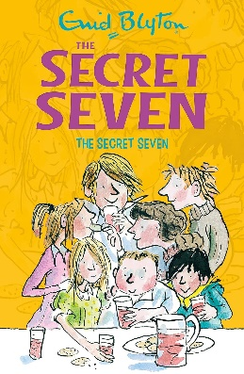 | Fairy vs Boy  - Jenny McLachlan  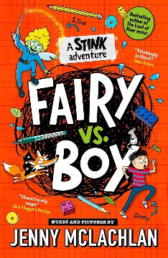 | The Angel of Nitshill Road  - Anne Fine  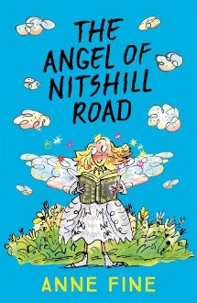
Key texts/writing stimulus |  | Stone Age Boy  – Satoshi Kitamura  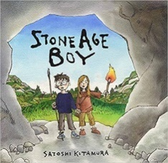  Inside the villains  - Clotidle Perrin  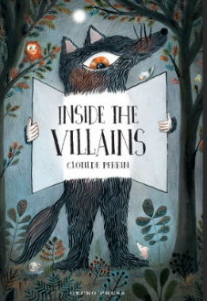  The last wolf  - Mini grey  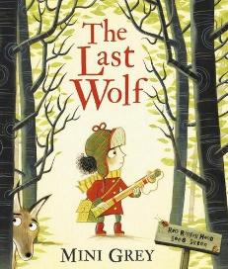 | Tuesday  - David Weisner  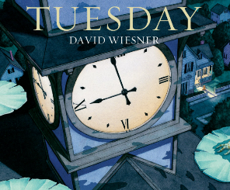 | The Tin Forest  – Helen Ward  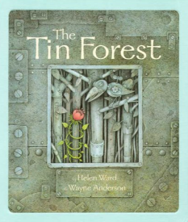  The magic box  - Kit Wright  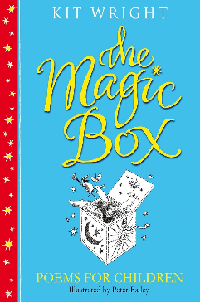 | The secret of black rock  – Joe Todd-Stanton  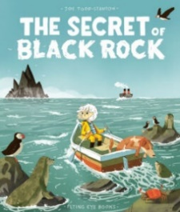  Magical Creatures  - Meg Clibbon  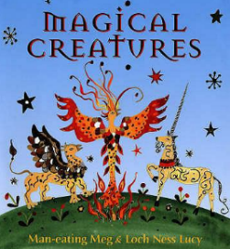 | Dear Greenpeace  - Simon James  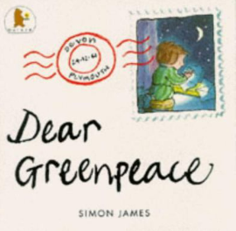 | Ocean meets the sky  - Eric Fan  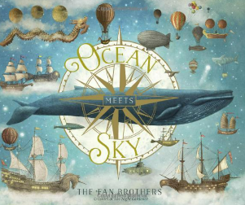
Writing outcomes | Fiction  Non Fiction  Poetry | Non-chronological report  - Stone Age Boy  Character description  Inside the villains by Clotidle Perrin  Narrative (Adapted fairytale) for the character from character description  - The last wolf by Mini grey | Narrative  - Tuesday by David Weisner  Chronological report (newspaper report)  - Tuesday by David Weisner | Diary entry  - The Tin forest by Helen Ward  Poetry  - The Magic Box by Kit Wright | Narrative (Fictional Legends - Mythical legend)  - The Secret of Black Rock by Joe Todd-Stanton  Non-chronological report  - Magical creatures by Meg Clibbon | Letter writing (to enquire and inform)  - Dear Greenpeace by Simon James  Poetry  City Jungle by Pie Corbett  - Free verse | Narrative (Fantasy story)  - Ocean meets the sky by Eric fan  Setting description  Persuasive advert  - Journey series by Aaron Becker OR linked to Geography learning
Stages of Writing | - Engage with a stimulus - Examine real life and model texts of that genre - Learn the features of and language type of the genre - Practice the composite aspects of the text (such as intro, middle, conclusion) - Plan effectively - Complete and extended piece of writing drawing on modelling and real-life examples - Edit the writing based on previous learning and feedback - Publish a final piece
Ongoing writing objectives throughout year | Year 3 | Ongoing objectives across Year 3:  Plan writing:  - discuss writing similar to that which they are planning to write in order to understand and learn from its structure, vocabulary and grammar  - discuss and record ideas using simple planning frames  Draft and write  Evaluate and edit, including proposing changes to grammar and vocabulary to improve consistency  Proof-read for spelling and punctuation errors
 | Year 4 | Ongoing objectives across Year 4:  Plan writing:  - discuss writing similar to that which they are planning to write in order to understand and learn from its structure, vocabulary and grammar  - consider levels of formality in non-fiction texts  - discuss and record ideas using a standard planning frame  Draft and write  Evaluate and edit, including proposing changes to grammar and vocabulary to improve consistency  Proof-read for spelling and punctuation errors
Composition | Year 3 | Composition:  - In narratives, create settings  - In narratives develop understanding of characters and how authors convey characters  - (Y2) Orally compose and rehearse sentences before writing  - (Y2) Re-read to check that their writing makes sense; including consistent use of tense  - (Y2) leaving spaces between words that reflect size of letters  - Introduce organisational devices of headings and sub headings appropriate to the text form  - Begin to assess the effectiveness of others’ writing with reference to writing plan  - Proof read to ensure correct use of capital letters, full stops and question marks to demarcate sentences  - (Y2) Continue to leave spaces between words that reflect size of letters | Composition:  - In narratives, create characters  - Continue to orally compose and rehearse sentences before writing  - Orally compose and rehearse new sentence structure knowledge before writing  - Recognise correct subject/verb agreement (e.g. We are/I am, There are/There is) in spoken language  - (Y2) Leave spaces between words that reflect size of letters  - Introduce paragraphs to organise information writing  - Develop organisational devices of headings and sub headings related to the text form  - (Y2) Re-read to check that their writing makes sense; including consistent use of tense  - Assess the effectiveness of others’ writing with reference to planning  - Proof read to ensure use of capital letters, full stops, question marks and exclamation marks to demarcate sentences  - Read aloud their poetry, to a group or the whole class, using appropriate intonation | Composition:  - In narrative, create characters and plot  - Orally compose and rehearse sentences ahead of writing  - Continue to develop use of paragraphs to organise related information  - Continue to assess the effectiveness of others’ writing with reference to agreed success criteria  - Re-read to check that writing makes sense, including consistent use of verb forms (simple and progressive from Y2)  - Proof read to ensure accurate sentence demarcation: capital letters, full stops, question marks and exclamation marks  - Recognise correct subject/ verb agreement (e.g. We are/ I am, There are/ There is) in spoken language  - (Y2) Leave spaces between words that reflect size of letters | Composition:  - In narratives, creating setting, characters and plot  - Further develop orally composing and rehearsing new sentence structure knowledge before writing  - Develop vocabulary choices through word families based on common words, showing how words are related in form and meaning in spoken and written form  - Organise writing into paragraphs for non-fiction compositions  - Continue to develop the use of organisational devices (headings and sub headings) to support the reader  - Begin to suggest improvements linked to evaluation of effectiveness for others’ writing  - (Y2) Continue to focus on leaving spaces between words that reflect size of letters  - Proof read to ensure correct application of all KS1 punctuation  - Recognise correct subject/verb agreement (e.g. We are/I am, There are/There is) in spoken language | Composition:  - Continue to organise writing into paragraphs for non-chronological reports  - Identify cohesion within and across sentences.  - Continue to orally compose and rehearse new sentence and expand structures before writing  - Identify correct subject/verb agreement (e.g. We are/I am, etc) where used  - Begin to assess the effectiveness of own writing with reference to planning  - Discuss poetry writing similar to that which they are planning to write and use models to provide given structure  - Read aloud own poetry, to a group/ the whole class, using intonation & volume  - Suggest improvements linked to evaluation of effectiveness of own writing Consider the writing style and authorial voice developed in model text based on structure, vocabulary and grammar | Composition:  - Explore models to understand and learn from their structure, vocabulary and grammar  - Organise writing into paragraphs  - Proof-read to ensure correct application of all KS1 punctuation  - Recognise correct subject/verb agreement (e.g. We are/I am, There are/There is) in spoken language  - Continue to assess the effectiveness of own writing with reference to original planning and make suggested improvements  - Revisit orally composing and rehearsing sentences ahead of writing  - Explore models to understand and learn from their structure, vocabulary and grammar  - Record ideas linked to ‘real experience’ using familiar planning template  - Re-read to check that their writing makes sense and that verb tense is consistent
 | Year 4 | Composition:  - Discuss writing similar to that which they are planning to write (poetry structure)  - (Y2) Leave spaces between words that reflect size of letters  - (Y2) Consolidate expanded noun phrases to describe and specify information for the reader  - (Y3) Recognise correct subject/verb agreement (e.g. We are/I am, There are/There is) in spoken language  - (Y3) Proof read to ensure correct application of all KS1 punctuation  - In narratives, create characters, settings  - (Y3) Revisit how to organise writing into paragraphs for non-fiction as a way to group related material using headings and sub-headings  - In non-narrative, use organisational devices to support layout  - Organise information into paragraphs of expanded ideas  - Continue to identify correct use of past and present tenses | Composition:  - Compose and rehearse sentences orally  - Focus on building vocabulary choices  - (Y3) Revisit how to organise writing into paragraphs for non-fiction as a way to group related material using headings and sub-headings  - (Y3) Proof read to ensure correct application of all KS1 punctuation  - (Y2) Further embed leaving spaces between words that reflect size of letters  - In narratives, create and describe settings and characters  - Introduce author’s use of paragraphs to organise ideas within narrative  - (Y3) Proof-read to ensure correct application of all KS1 punctuation  - Consider correct subject/verb agreement (e.g. We are/I am, There are/There is) in written form  - Discuss writing similar to that which they are planning to write | Composition:  - In narratives, creating setting and plot  - Plan and use paragraphs to organise chronology of ideas in narrative  - Continue to use past and present tenses correctly, including range of known verb forms (progressive and perfect)  - Use paragraphs to organise ideas, e.g. opening/ closing instruction paragraphs  - In non-narrative material, use simple organisational devices  - Compose own poetry using varied vocabulary and grammar choices  - (Y3) Vary sentence structure by using a range of known Y3 conjunctions, adverbs and prepositions to support cohesion and express time, place or cause  - Develop correct use of subject/verb agreement (e.g. We are/I am, There are/There is) in written form | Composition:  - In narratives, create characters and plot  - In non-narrative material, use simple organisational devices  - Plan and develop a sequence of paragraphs to organise the chronology of narratives  - Plan and develop a sequence of paragraphs to organise writing around a theme for explanations  - Consider the required level of formality for writing  - Develop accuracy in using past tense, including progressive and perfect forms  - Proof read to identify and correct the accurate use of plural and possessive –s  - Proof read for correct application of known spelling, punctuation and tense | Composition:  - In narratives create settings and plots  - Vary the range of sentence structures used within individual paragraphs  - Further develop organisation of information into coherent paragraphs  - Consistently maintain past tenses correctly across whole composition, and present tense, where relevant  - Continue to embed proof reading for correct use of punctuation  - Focus on ensuring subject/verb agreement (e.g. We are, There is)  - Consider non-chronological writing similar to that which they will be writing  - Understand structure and level of formality depending on audience  - Revisit and select non-fiction organisational devices to support layout  Continue to evaluate effect of composition and reference to original plan | Composition:  - In narratives setting, characters and plot  - Select organisational devices to support reader engagement with layout  - With increasing independence, organise narrative into paragraphs  - Proof read for correct application of known punctuation  - Evaluate effect of composition and reference to original plan  - Further develop organisation of information into coherent paragraphs  - Continue to evaluate effect of composition and reference to original plan
Grammar and punctuation | Year 3  New learning  Recap/refine | Grammar & punctuation:  - (Y2) Revisit co-ordinating conjunctions to join clauses  - (Y2) Revisit using expanded noun phrases to describe for the reader  - (Y2) Punctuate sentences with capital letters and full stops  - (Y2) Reintroduce using statement sentences  - (Y2) Revisit commas to separate items in a list  - (Y2) Continue to secure apostrophes for contractions  - Introduce expanding sentences using conjunctions (subordinating and coordinating) | Grammar & punctuation:  - Begin to expand sentences using conjunctions to express cause  - (Y2) Revisit apostrophes to mark where letters are missing in spelling and to mark singular possession in nouns  - Introduce expanding sentences using prepositions to express place  - (Y2) Use a combination of co-ordinating and subordinating conjunctions to join clauses -building on conjunctions introduced in Autumn 1  - (Y2) Use expanded noun phrases to specify information for the reader  - (Y2) Continue to focus on basic sentence demarcation with capital letters and full stops  - (Y2) Reintroduce using question sentences and question marks  - Expand sentences using conjunctions  - (Y2) Use expanded noun phrases to provide detail for the reader | Grammar & punctuation:  - Begin to identify ‘a’ or ‘an’ according to whether the next word begins with a consonant or a vowel  - Begin to expand sentences using adverbs to express time in narratives  - Continue to expand sentences using prepositions to express place  - Begin to identify how inverted commas can be used to punctuate direct speech  - (Y2) Revisit apostrophes to mark where letters are missing in spelling and to mark singular possession in nouns | Grammar & punctuation:  - Develop the use of inverted commas to punctuate direct speech begin to identify how inverted commas can be used to punctuate direct speech  - Continue to identify correct use of ‘a’ or ‘an’ through proof reading  - Further practise using full range of KS1 punctuation to demarcate sentences and support the reader  - Develop expanded sentences using adverbs to express time in narrative  - Expand phrases and sentences using expanded noun phrases and adverbs to provide detail for the reader | Grammar & punctuation:  - Begin to identify the present perfect form of verbs instead of the simple past  - Vary sentence structure by using a range of conjunctions, adverbs and prepositions to support cohesion and to add detail  - Continue to proofread to ensure correct application of all KS1 punctuation  - Embed correct use of ‘a’ or ‘an’ when proof reading  - Expand and select new vocabulary  - Revisit and identify difference between sentence types (statement, question, command and exclamation) and incorporate range into own writing  - Continue to vary sentence structure by using a range of conjunctions, adverbs and prepositions to support cohesion and to add detail | Grammar & punctuation:  - Vary sentence structure by using a range of conjunctions, adverbs and prepositions to support cohesion and to add detail  - Recognise the use of commas to separate main and subordinating clauses  - Focus on maintaining consistent tense across whole composition; including present perfect form  - Use ‘a’ or ‘an’ according to whether the next word begins with a consonant or a vowel
 | Year 4  New learning  Recap/refine | Grammar & punctuation:  - (Y3) Revise commas to separate items in a list and to separate clauses when constructing complex sentences  - (Y2) Consolidate expanded noun phrases to describe and specify information for the reader  - (Y3) Vary sentence structure by using a range of known conjunctions, adverbs and prepositions from Y3 to support cohesion and express time, place or cause  - (Y3) Correct choice and consistent use of past tense throughout writing  - (Y2/3) Embed use of apostrophes to mark where letters are missing in spelling and to mark singular possession in nouns  - (Y3) Continue to vary sentence structure by using a range of known conjunctions, adverbs and prepositions from Y3 to support cohesion and to express time, place or cause  - Introduce fronted adverbials  - Begin to use commas after a fronted adverbial | Grammar & punctuation:  - (Y3) Vary sentence structure by using a range of known conjunctions and adverbs to support cohesion and to express time or cause, as appropriate  - (Y3) Ensure correct choice and consistent use of past tense throughout writing; including use of present perfect form  - Introduce noun phrases expanded by the addition of modifying adjectives  - (Y2 & Y3) Revisit apostrophes to mark where letters are missing in spelling and to mark singular possession in nouns  - (Y3) Vary sentence structure by using a range of known conjunctions, adverbs and prepositions from Y3 to support cohesion and to express time, place or cause  - (Y3) Vary sentence structure by using known adverbs and prepositions from Y3 to support cohesion and to express place or cause  - Use past and present tenses correctly  - Develop noun phrases expanded by the addition of modifying adjectives  - Develop use of fronted adverbials and demarcate with commas | Grammar & punctuation:  - (Y2/3) Revisit apostrophes to mark where letters are missing in spelling and to mark singular possession in nouns  - (Y3) Vary sentence structure by using a range of known conjunctions, adverbs and prepositions from Y3 to support cohesion and to express time or place  - Introduce use of pronouns to aid cohesion and avoid repetition  - Continue to use fronted adverbials with commas to expand sentence detail  - Construct expanded noun phrases modified by prepositional phrases  - Begin to vary the position of clauses within a sentence and use commas to separate clauses where required  - Identify the grammatical difference between plural and possessive –s | Grammar & punctuation:  - Identify the grammatical difference between plural and possessive –s  - (Y3) Revisit use of inverted commas and other direct speech punctuation  - Select personal pronouns or nouns within and across sentences to aid cohesion and avoid repetition  - Continue to construct expanded noun phrases modified by adjectives, nouns and preposition phrases to provide detail for the reader  - Continue to vary sentence structure ( including the use of fronted adverbials) and the position of clauses within sentences and understand the effect of the different position | Grammar & punctuation:  - Introduce apostrophes to mark plural possession  - Continue to vary sentence structure including the use of fronted adverbials and subordinate clauses, and expanded noun phrases by selecting a wider range of adventurous modifiers  - Select appropriate pronouns or nouns to aid cohesion and avoid repetition  - Further develop use of inverted commas and other punctuation to indicate direct speech (both writing outcomes) include a wider range of verb forms  - Select and apply appropriate formal or informal vocabulary for audience  - Continue to select and apply range of punctuation to support coherence  - Develop cohesive individual paragraphs with links across sentences  - Identify and accurately use a range of verb forms for past or present tense | Grammar & punctuation:  - Continue to use apostrophes to mark plural possession, where relevant  - Vary the range of sentence structures used within individual paragraphs (simple, compound and complex)  - Continue to construct expanded noun phrases by selecting a wider range of modifiers with shades of meaning  - Embed accurate use of past and present tenses, and include a wider range of verb forms  - Select and apply appropriate vocabulary  - Continue to select and apply appropriate punctuation
Wider curriculum |  | The History detectives – stone age to iron age  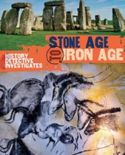  Usborne – 24 hours in the stone age  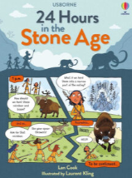  The secrets of stonehenge  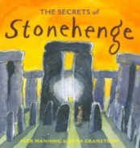  The pebble in my pocket  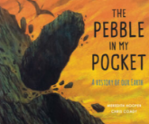  The street beneath my feet  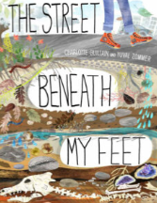 | Bones  - Steve Jenkins  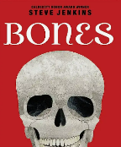  Usbourne – See inside your body  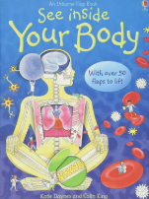  What’s eating you?  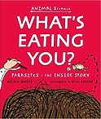  A journey through the digestive system.  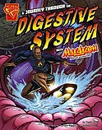  Human body  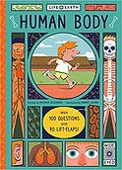 | The History detectives – stone age to iron age  Usborne – 24 hours in the stone age  The secrets of stonehenge | Rivers: an incredible journey from source to sea    Water  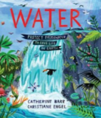 | The magic and mystery of trees  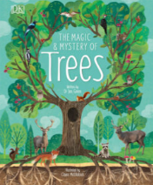  I ate sunshine for breakfast  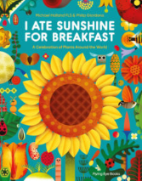 | Step into science - Light  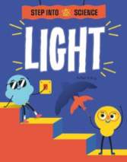  How it works: Light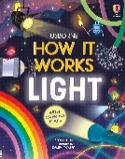  Foxton Primary Science: LKS2 - Light