 |  | Autumn 1 | Autumn 2 | Spring 1 | Spring 2 | Summer 1 | Summer 2
Topics | History  Geography  Science | The Great Fire of London  Use of everyday materials | The UK | Communication through time  Animal including humans | Europe | Famous people who influenced the world  Plants | The World  Living things and their habitats
Reading for Pleasure |  | Repetitive language  - Rhino’s don’t eat pancakes  - Funnybones  - Fox in socks  - Squash and a squeeze  - Not now Bernard! | Traditional tales  - Who’s afraid of the big bad book  - The three little wolves and the big bad pig  - Jack and the beanstalk by Richard walker  - Little red reading hood  - Rumplestiltskin | Animals  - Giraffe’s can’t dance  - Dogs in space  - The guard dog  - The squirrels who squabbled  - How to hide a lion | Fantasy Stories  - The Tear Thief  - Look Up!  - Leon and the place Between  - Float  - Flat Stanley – chapter book | Climate change  -What the elephant heard  - The Last tree  - Here We Are  - A Walk in the Woods  - Greta and the Giants | Stories from other cultures  - Bringing the rain to Kapiti Plain  - Mama Panya’s pancakes  - Handa’s hen  - Handa’s surprise  - One Plastic Bag
Key texts/writing stimulus |  | There is no dragon in this story  - Lou Carter  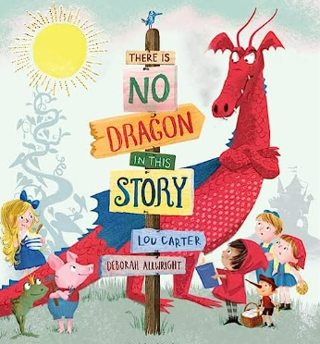  Tell me a dragon  - Jackie Morris  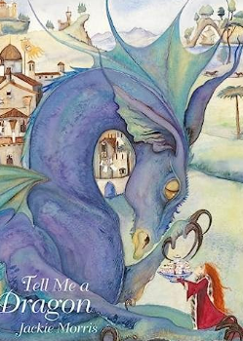 | Vlad and the great fire  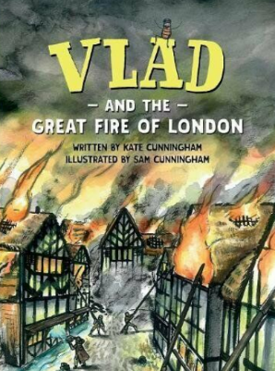  The Polar Express   | The Owl who was afraid of the dark  - Jill Tomlinson  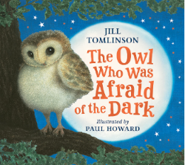 | The disgusting sandwich  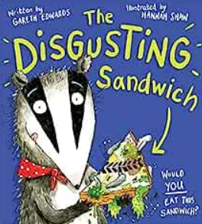 | Greta and the Giants  - Zoe Tucker  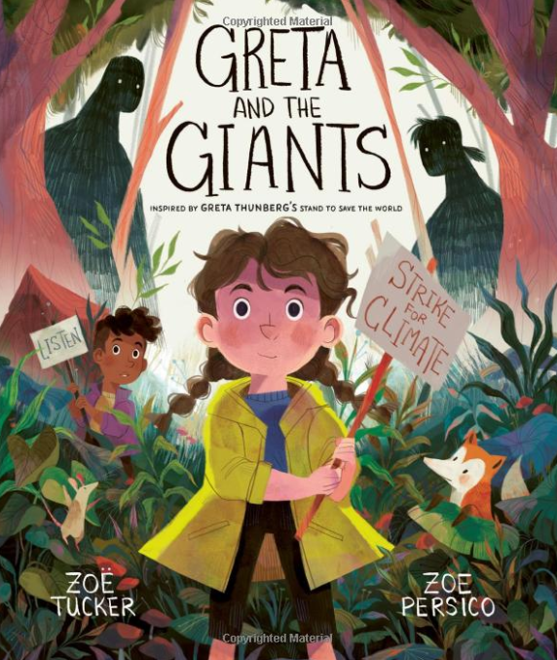  The last tree  - Emily Haworth-Booth  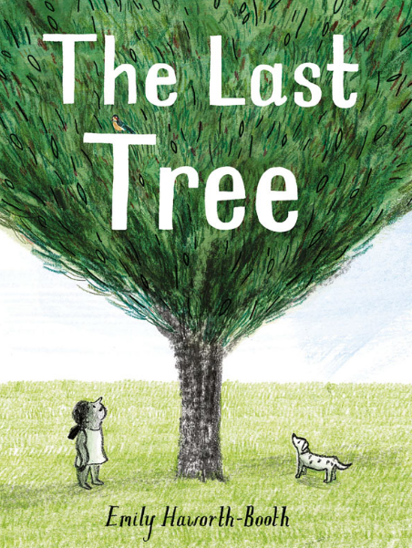 | Handa’s surprise  - Eileen Browne  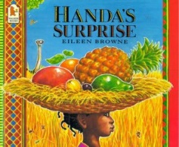  One Plastic Bag  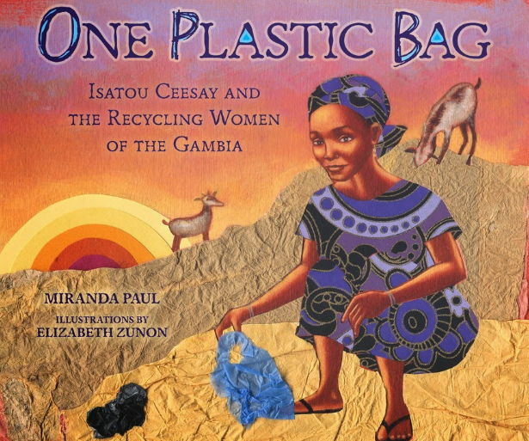
Writing outcomes | Fiction  Non Fiction  Poetry | Adapted fairy-tale  - There is no dragon in this story  Descriptive poem  - Tell me a dragon | The Polar Express  - Instructions How to make a hot chocolate  Diary writing  - Vlad and the Great fire of London | Narrative – Creating a new chapter  - The owl who was afraid of the dark  Non-chronological report  - Barn Owls | Recount  - Geography trip – Sherwood Forest  Journey story  - The disgusting sandwich | Letter writing – persuasive  - Greta and the giants/climate change  Explanation text  - Life cycle of a plant | Narrative – story from a different culture  - Lila and the secret of the rain  Fact file of a significant person  - Linked to topic
Ongoing writing objectives throughout year |  | Ongoing objectives across the year:  - Develop positive attitudes to and stamina for writing by writing for different purposes  - Before beginning to write consider writing down ideas and/or key words, including new vocabulary; encapsulating what they want to say, sentence by sentence  - Make simple additions, revisions and corrections by evaluating their writing with the teacher and other pupils  - Read aloud what they have written with appropriate intonation to make the meaning clear  Deliberate steps should be taken to increase pupils’ vocabulary and their awareness of grammar so that they continue to understand the differences between spoken and written  language. (NC Reading non-statutory)
Composition |  | - Write for different purposes, about real events and poetry  - Write a narrative about personal experiences and those of fictional characters  - Plan own writing using simple scaffold  - Introduce the use of the suffix –ly to turn adjectives into adverbs  - Practise proof reading to check for errors in punctuation and common known spellings  - Re-read to check writing makes sense including appropriate content and consistency of grammar choices  - Introduce how to make simple revisions to writing and continue to make simple corrections | - Write a coherent narrative  - Write about real events and for different purposes, including poetry  - Plan what they are going to write about  - Re-read to check that their writing makes sense and verbs to indicate time are correct  - introduce how to make simple additions to writing and continue to make simple corrections and revisions  - Proof read to check for errors in spelling, grammar and punctuation | - Write for different purposes, about real events and poetry  - Write a narrative about personal experiences and those of fictional characters  - Plan own writing using simple scaffold  - Introduce the use of the suffix –ly to turn adjectives into adverbs  - Practise proof reading to check for errors in punctuation and common known spellings  - Re-read to check writing makes sense including appropriate content and consistency of grammar choices  - Introduce how to make simple revisions to writing and continue to make simple corrections | - Write a coherent narrative  - Write about real events and for different purposes, including poetry  - Plan what they are going to write about  - Re-read to check that their writing makes sense and verbs to indicate time are correct  - introduce how to make simple additions to writing and continue to make simple corrections and revisions  - Proof read to check for errors in spelling, grammar and punctuation | - Writing own imaginary narrative plots  - Writing about personal real experiences (chronological order)  - Develop sentences in chronological order and maintain coherence throughout  - Writing for different purposes: simple explanations  - Vary sentence structures to engage the reader  - Continue to check for sense and verbs to indicate time are in the correct tense  - Proofread to check for errors in spelling, grammar and punctuation  - Continue to make simple additions and revisions to enhance the writing and provide precise detail for the reader  - Writing ideas down including new vocabulary before beginning to write  - Leave spaces between words that reflect size of letters when publishing  - Read aloud what they have written with appropriate intonation for meaning | - Writing own narrative based on familiar story  - Continue to develop varied sentence structures with simple, compound and complex sentences  - Reread writing is ensure sentences and whole composition is coherent and makes sense, including consistency of tense  - Continue to leave spaces between words that reflect size of letters  - Further embed making simple revisions and additions to compositions to improve overall composition  - Writing for different purposes  - Develop vocabulary choices
Grammar and punctuation | New learning  Recap/refine | - Introduce and use different sentence forms: commands  - Introduce and use subordinating conjunctions to join clauses (using when, because) in spoken and written forms  - Vary sentence structure by include co-ordinating conjunctions  - Revisit use of question sentences and demarcating with question marks  - Continue to practise sentence demarcation  - Use expanded noun phrases to describe  - Introduce and use apostrophes to mark where letters are missing in spelling  - Introduce the progressive form of past and present verb tenses | - Consistently apply sentence demarcation  - Use sentences with different forms: statement, question, command  - Introduce exclamations and revisit use of the exclamation mark  - Extend the range of subordinating conjunctions to joining clauses (using when, if, that, or because)  - Begin to use commas to separate items in a simple list  - Use apostrophes to mark where letters are missing in spelling -contracted form  - Recognise apostrophes to mark singular possession  - Continue to focus on the progressive form of past and present verbs  - Use a range of coordinating and subordinating conjunctions to joining clauses | - Introduce and use different sentence forms: commands  - Introduce and use subordinating conjunctions to join clauses (using when, because) in spoken and written forms  - Vary sentence structure by include co-ordinating conjunctions  - Revisit use of question sentences and demarcating with question marks  - Continue to practise sentence demarcation  - Use expanded noun phrases to describe  - Introduce and use apostrophes to mark where letters are missing in spelling  - Introduce the progressive form of past and present verb tenses | - Consistently apply sentence demarcation  - Use sentences with different forms: statement, question, command  - Introduce exclamations and revisit use of the exclamation mark  - Extend the range of subordinating conjunctions to joining clauses (using when, if, that, or because)  - Begin to use commas to separate items in a simple list  - Use apostrophes to mark where letters are missing in spelling -contracted form  - Recognise apostrophes to mark singular possession  - Continue to focus on the progressive form of past and present verbs  - Use a range of coordinating and subordinating conjunctions to joining clauses | - Introduce the use of suffixes to form adjectives such as –ful/-less  - Continue to use expanded noun phrases to add detail for the reader  - Further develop application of the progressive verb form  - Use exclamation sentences and exclamation marks to demarcate  - Use co-ordinating & subordinating conjunctions to join clauses  - Continue to embed range of sentence demarcation  - Revisit and use commas to separate items in a list  - Begin to use apostrophes to mark singular possession in nouns  - Continue to accurately use the range of sentence punctuation including capital  - Explore and develop expanding noun phrase and alternative adjectives | - Use range of sentence types: statements, questions, exclamations and commands (where relevant)  - Continue to embed range of basic sentence demarcation  - Develop use of apostrophes to mark singular possession and contraction  - Identify and maintain appropriate tense  - Embed use of expanded noun phrase
Wider Curriculum |  | The great fire of london    The buildings that made London  - David Long and Josie Shenoy  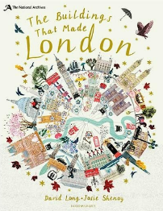 | The Big Book of the UK  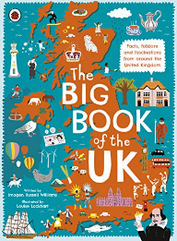  The adventures of Robin Hood – Marcia Williams  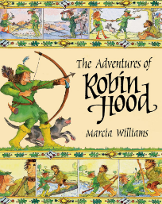  A Walk in London – Salvatore Rubbino  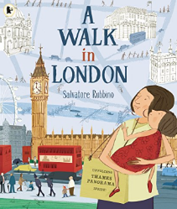 | Growing and changing, all about life cycles – Ruth Owen  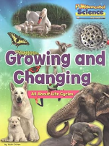  Animal Babies – Martin Jenkins and Jane McGuiness  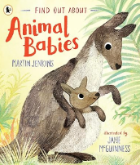 | A Walk in Paris - Salvatore Rubbino  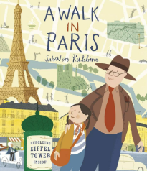  The Usborne First Atlas  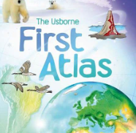 | Ten seeds – Ruth brown  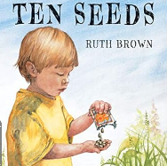  The amazing life cycle of plants – Kay barnham  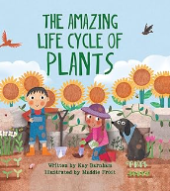  Roots, Stems, leaves and flowers  - Ruth Owen  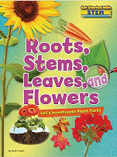 | Me on a Map – Joan Sweeney  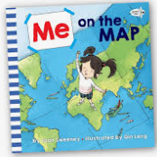  The Tiny Seed – Eric Carle    One day on our blue planet – book collection

