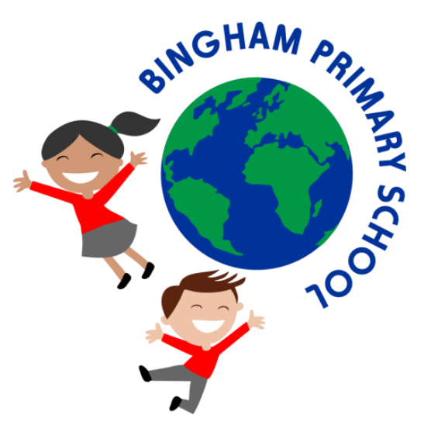

Early Years Policy
May 2024

Curriculum vision and values
At Bingham Primary School we firmly believe that Early Years is truly the foundation for life-long learning. We provide our children with outstanding educational opportunities in an inspiring and well resourced environment.
We aim to ensure our learners develop skills and knowledge over time that give them the tools they need to be successful, happy learners.
Our curriculum teaches all our children to be able to make decisions, reason about their choices, understand the consequences of decisions they make and to choose the appropriate, most effective tools and methods to best achieve the results they are looking for.
At the heart of everything we do is a grounding in the basic skills of reading, writing and maths. We want our children to be able to fully access the richness of all the subjects because they are confident readers, writers, and number manipulators!
Our curriculum reflects our core values. At Bingham Primary School, we believe in:
• Making learning fun and inspirational so that children will enjoy their schooling.
• Fostering positive attitudes, respect, and inclusivity so that all our children feel safe and valued.
• Building confidence in our children so that they can solve problems, show resilience, and work effectively as a team.

The Bingham Belief
The 'Bingham Belief' encompasses all our Vision and Values in the phrase:
"We believe that if we work hard and never give up, we can achieve anything!"

Our school song helps the children to understand our vision and values, as well as the expectations and aspirations we have for their development as members of our school community.

“We can be who we want to be. Everything is in reach for me.
We love learning, which is fun. Solving problems, with everyone.
We are polite, and we care for all. Include everyone, don’t give up if we fall.
We can be who we want to be. Everything is in reach, for me.”

Introduction
At Bingham Primary School, we are committed to providing all children with an excellent start to their formal education. We provide opportunities that are engaging and allow our children to investigate and discover a love of learning. We encourage the children to be independent and support them through structured activities to develop their knowledge and apply this into their independent learning through our Plan-Do-Review sessions.

Aims
In the Early Years we aim to ensure all our children are confident to be:
- Independent learners.
- Inquisitive problem solvers.
- Confident to try new activities showing resilience.
- Safe and secure.
- Keen learners and advocates of our ‘Bingham Belief.’

Curriculum
In line with the Early Years Foundation Stage Framework 2021 our curriculum is structured within the seven areas of learning which are all interconnected. These areas include three Prime Areas, Personal, social and emotional development (PSED), Communication and language (CL), and Physical development (PD) and four Specific Areas Literacy, Mathematics, Understanding the World and Expressive Arts and Design. Another further key element of the Early Years Foundation Stage is the Characteristics of Effective Teaching and Learning. This focuses on the different ways that children learn. We continually observe, assess, teach and provide opportunities for our children to develop their learning at Bingham Primary School. We are fortunate to have a large outside area that the children have free-flow access to during their plan-do-review sessions.

Planning
At Bingham Primary School, the Early Years Curriculum for both our Nursery and Reception classes is taught through topics which are chosen to engage and motivate. We follow the children’s interests and pride ourselves in providing a balance between taught sessions and structuring our learning environment to allow the children to discover, apply and investigate independent application of new knowledge.

Assessment and Progress
The Reception Baseline Assessment (RBA) is a government assessment tool is used to assess children’s understanding on entry to school. This information allows us to ensure that we are delivering the curriculum at the appropriate level of challenge for our children.

Children are continually observed, and progress is monitored on a regular basis. A range of assessment for learning strategies are used to help measure progress, understand learning needs, plan activities, and identify any need for support. Our children are provided with resources and tasks based on these assessments to help them achieve their next steps in learning. Assessments and observations are recorded using ‘Evidence Me’ which allows staff to record each child’s learning. Parents can access and add additional observations onto this system for their child.

To further aid children ‘knowing more and remembering more’, each class has a ‘Knowledge Box’. Following appropriate wider curriculum sessions, key questions are put into the ‘Knowledge Box’ for review throughout the year. The ‘Knowledge Box’ is then used as a retrieval practise tool at the beginning of each lesson.

At Bingham Primary School, assessment is an integral part of the teaching process. Assessment is used to inform planning and to facilitate differentiation. The assessment of children’s work is on-going to ensure that understanding is being achieved and that progress is being made.

The EYFS profile is a statutory assessment of children's attainment at the end of the early year’s foundation stage. This enables teachers to summarise Childrens’ progress towards the Early Learning Goals. We record each child’s level of development as ‘expected’, ‘working towards ‘or ‘above’ the expected level at the end of the reception year.

Special Educational Needs (SEN) and Inclusion
At Bingham Primary School our children are valued as individuals irrespective of their ethnicity, culture, religion, home language, background, ability, or gender.

As children begin in our nursery and reception classes they are monitored and supported to settle. Some children may have difficulty accessing the curriculum at the same level as their peers without scaffolding tasks, additional adult support and resources. This will be closely monitored, and we will follow the school procedures outlined in the Special Needs Policy.

If your child has an identified SEND we will work closely with their setting and yourself to ensure that we are in a position to meet their need when they begin at school.

Transition into Reception
Starting school can be a stressful time for both parents and children. At Bingham Primary School, we aim to support you and your child through this process through the following events.

We hold a parent induction meeting during the Summer term. This allows parents to meet the staff and have an overview of the support we offer their children as they begin school. It also allows staff to address practical issues such as school routines, uniform, PE kit, school dinners, including free school meals, and explain about the induction into Reception.

We support children by offering a nursery visit from a member of the EYFS team before starting school. This allows children to informally meet a teacher in a familiar environment. It also allows staff to discuss individual children’s needs with their current setting.

We also hold two taster sessions during the Summer Term in school, where the children can meet all the staff and their new class friends. Sessions are focused on learning names, class rules, and adapting to new routines. The children will also be offered lunch on one of their visits. Children joining school mid-year are also offered taster sessions for a smooth transition.

Safeguarding and Welfare
Children learn best when they are healthy, safe, and secure. We ensure their individual needs are met and that they have positive relationships with all the adults caring for them.

We follow the safeguarding and welfare requirements detailed in the ‘Keeping Children Safe in Education’ statutory guidance and ‘EYFS Statutory Guidance (2023)’. We also adhere to the schools safeguarding policy using CPOMS.

Children are taught how to stay safe when playing outside and learn how to be ‘Safety Inspectors’, checking for hazards daily.

We have clear and consistent expectations for behaviour and we manage behaviour effectively, in a manner appropriate for the children’s stage of development and individual needs, following the school behaviour policy, which is built around using restorative practice.

We are a healthy school and participate in the free fruit and milk for the under-fives scheme. We provide the universal infant-free school meal scheme where our school menu is regularly monitored by our school chef. We cater to those children who have special dietary requirements and have robust systems in place to ensure that all children receive the correct meal. Children are given a water bottle when they start school and fresh water is readily available throughout the day.

We actively teach children how to stay healthy by learning the importance of; eating a balanced diet, exercising regularly, maintaining personal hygiene, and dental care.

___________________________________________________________________________

We are aware of the need to review the school Early Years policy regularly so that we can take account of new initiatives and changes within the school.
The Local Governing Body, at their meeting in ________________, adopted this policy. It will be reviewed in ________________.

Signed:

______________________________________ (Head Teacher)

______________________________________ (Chair of LGB)

