 |  | Autumn 1 | Autumn 2 | Spring 1 | Spring 2 | Summer 1 | Summer 2
Topics | History  Geography  Science | Ancient Egyptians  Properties and changes of materials | The Northern Hemisphere | Ancient Greeks  Forces | North America – Earthquakes and Volcanoes  Earth and Space | Mayan Study  Animals including humans | North American Trade  Living things and their habitats
Whole Class Reading Texts |  | Secrets of a Sun King  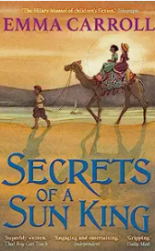  Shorter texts to rehearse reading domains |  | Nevermoor  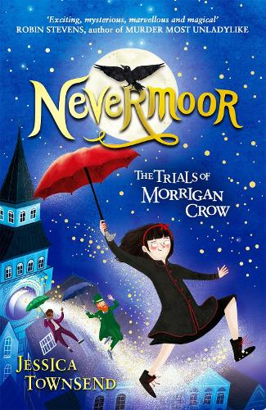  Shorter texts to rehearse reading domains |  | The boy at the back of the class  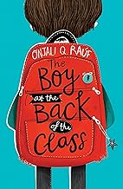  Shorter texts to rehearse reading domains
Reading for Pleasure – class novel |  | The Girl of Ink and Stars  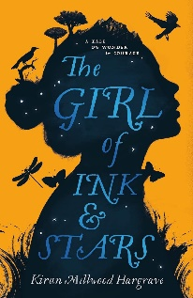 |  | Holes  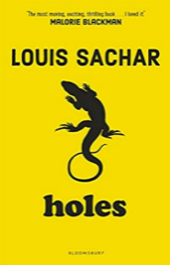 |  | Cosmic  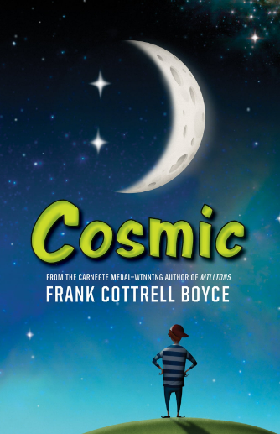
Key texts/writing stimulus |  | Marcy and the Riddle of the Sphynx  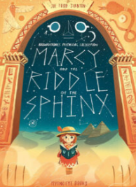 | The Highwayman   | Leo and the Gorgon’s curse  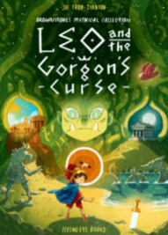 | The Dreadful Menace (film unit)  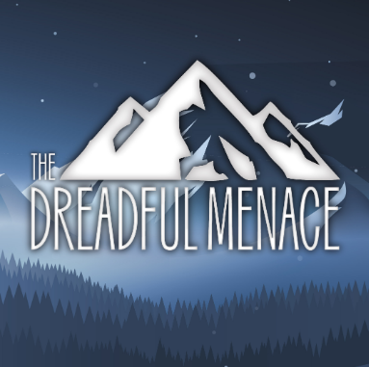  Hacker   | Holes  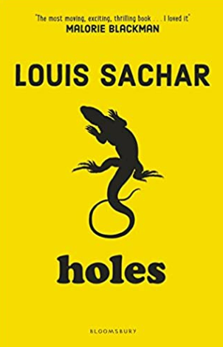 | Macbeth  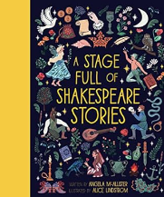  Cosmic
Writing outcomes | Fiction  Non Fiction  Poetry | Narrative (adventure story)  - Marcy and the riddle of the sphynx  Recount - Diary entry (1st person)  Explanation text  - mummification | Newsfeed  – discovery of Tutan Kahmun’s tomb  Biography  – Howard Carter  Narrative Poetry  - Highwayman | Narrative (Short myth and legends)  - Leo and the Gorgon’s curse  Balanced argument – Athens or Sparta?  Persuasive tourist leaflet  Assassin's Creed Odyssey: A Tour of Athens  Biography (Quick write)  - Children to choose influential musician? | Poetry – The Dreadful Menace (Literacy Shed clip)  Newsfeed  – Earthquake or volcano  Narrative – internal monologue (Hacker) | Narrative (prequel/sequel/missing chapter)  - Holes  Non-chronological report  Yellow spotted lizard - Holes  Explanation text  Year 6 - How to prepare for SATs  Year 5 – How to prepare for the MTC | Balanced argument - Macbeth  Narrative - Cosmic  Formal Letter to Downing Street  - courageous advocacy
Stages of Writing | - Engage with a stimulus - Examine real life and model texts of that genre - Learn the features of and language type of the genre - Practice the composite aspects of the text (such as intro, middle, conclusion) - Plan effectively - Complete and extended piece of writing drawing on modelling and real-life examples - Edit the writing based on previous learning and feedback - Publish a final piece
Ongoing writing objectives throughout year | Year 5 | Ongoing objectives across the year:  Plan writing:  - identifying the audience and purpose of the writing, selecting appropriate form and use other similar writing as models for their own (consider levels of formality where appropriate)  - noting and developing initial ideas using chosen planning frames, and drawing on reading and research  Draft and write:  - selecting appropriate grammar and vocabulary, understanding how such choices can change and enhance meaning  Evaluate and edit:  - including proposing changes to vocabulary, grammar and punctuation to enhance effects and clarify meaning  - Proof-read for spelling and punctuation errors
 | Year 6 | Ongoing objectives across the year:  Plan writing:  - identifying the audience and purpose of the writing, selecting appropriate form and use other similar writing as models for their own  - noting and developing initial ideas using chosen planning frames, and drawing on reading and research  Draft and write:  - selecting appropriate grammar and vocabulary, understanding how such choices can change and enhance meaning  Evaluate and edit:  - proposing changes to vocabulary, grammar and punctuation to enhance effects and clarify meaning  - distinguishing between the language of speech and writing and choosing the appropriate register  - Proof-read for spelling and punctuation errors
Composition | Year 5 | Composition:  - (Y4) Revisit use of paragraphs to organise ideas around a theme  - (Y4) Linking ideas within paragraphs using known cohesive devices (conjunctions, adverbs, pronouns)  - In narratives, begin to convey character through dialogue maintaining a balance of speech and description  - In narratives, considering how authors have developed characters in what pupils have read, listened to or seen visually  - Proof read for correct application of known punctuation from KS1/LKS2  - (Y4) Continue to evaluate the effectiveness of writing and develop with reference to planning | Composition:  - In narratives, begin to describe and develop atmosphere  - Use paragraphs to organise ideas around a theme for narrative and non-narrative compositions  - Further develop devices to build cohesion within paragraphs  - Convey character through dialogue maintaining a balance of speech and description  - Use further organisational and presentational devices to structure text and to guide the reader  - Assess the effectiveness of own and others’ writing with reference to success criteria and audience  - Continue to proof read for correct application of known punctuation from KS1/LKS2 | Composition:  - In narratives, continue to develop descriptive settings and characters  - Introduce how to link ideas across paragraphs using adverbials of time and number  - Continue to develop use of paragraphs to organise ideas using a variety of known known sentence structures and sentence lengths (simple, compound, complex)  - Revisit and develop subject and verb agreement when using singular and plural  - Assess the effectiveness of own writing with reference to planning and agreed success criteria to achieve impact  - Proof read for correct application of known punctuation from KS1/LKS2 | Composition:  - In narratives, develop character and atmosphere  - Select appropriate vocabulary, understanding how choices change & enhance meaning  - Select appropriate presentational devices to structure text and to guide the reader  • Develop how to link ideas across paragraphs using adverbials of time and place  • Further develop the structure of paragraphs with a variety of sentence structures  • Continue to assess the effectiveness of own and others’ writing reference to plan  • Continue to develop correct subject/ verb agreement when using singular and plural  • Read aloud their own writing, to a group or the whole class, controlling the tone and volume so the meaning is clear  - Proof read for correct application of known punctuation and spelling | Composition:  - In narratives, continue to develop descriptive settings and characters  - In narratives, continue to describe atmosphere  - In narratives, develop the use of dialogue to convey character and/ or advance the action  - Evaluate the effectiveness of own writing with reference to agreed success criteria  - Continue to develop selecting appropriate organisational devices to structure text  - Continue to develop the structure of paragraphs by using a variety of sentence structures  - Further develop devices to build cohesion within and across paragraphs  - Begin to precise longer passages  - Continue to develop the structure of paragraphs by using a variety of sentence suitable for informal register  - Read aloud their own writing, to a group or the whole class, controlling the tone and volume so the meaning is clear | Composition:  - In narratives, convey character and advance the action through dialogue  - In narratives, maintain a balance of narration and dialogue and/ or monologue  - Continue to embed a range of devices to build cohesion within and across paragraphs, including by changing tense  - Proofread for correct application of known punctuation  - Continue to develop how to evaluate the effectiveness of others’ writing with reference to agreed success criteria  - Continue to develop selecting appropriate organisational and presentational devices to structure text  - Continue to precise longer passages
 | Year 6 | Composition:  - In narratives, describe settings and characters  - (Y3/4/5) Revisit devices to build cohesion within a paragraph  - (Y3/4/5) Use paragraphs to organise ideas  - (Y5) Revisit linking ideas across paragraphs using adverbials  - Further develop vocabulary choices by understanding how words are related by meanings of synonyms and antonyms  - Further develop vocabulary choices to convey specific information  - Choose organisational and presentational devices to structure text and to guide the reader (for example, bullet points) | Composition:  - In narratives, build atmosphere  - (Y5) Revisit integrating dialogue to convey character  - Select cohesive devices to link paragraphs  - Use ellipsis to link ideas across paragraphs -for effect Precis longer passages  - Select verb forms appropriate to text conventions including passive to affect the presentation of information in a sentence  - Ensuring correct subject and verb agreement when using singular and plural, distinguishing between the language of speech and writing and choosing the appropriate register  - Continue to develop vocabulary choices by understanding how words are related by meanings of synonyms  - Understand the difference between structures typical of informal speech and appropriate for formal speech and writing  - Choose organisational and presentational devices to structure text and to guide the reader (for example, bullet points) | Composition:  - In narratives, continue to integrate description of settings and characters  - In narrative, focus on how to build atmosphere  - Distinguishing between the language of speech and writing and choosing the appropriate register for selected text form  - Choose organisational and presentational devices to structure text and to guide the reader/ speaker  - Continue to ensure correct subject and verb agreement when using singular and plural  - Select appropriate cohesive devices to link ideas across paragraphs including ellipsis and referencing back to previous points  - Ensure consistency of selected tense(s) is maintained  - Assess the effectiveness of own and others’ writing reference to plan | Composition:  - In narratives, describe settings, characters and atmosphere  • Select similar writing as models for their own  - Continue to integrate dialogue to convey character and advance the action  - Continue to understand the difference between registers of informal speech and writing  - Select between different structures for informal speech and structures appropriate for narrative writing  - Select appropriate cohesive devices to link ideas across paragraphs, including use of ellipsis to link ideas across paragraphs -for effect  - Draw on reading and research for individual compositions  - Choose further organisational and presentational devices to structure text and to guide the reader through the information (e.g. headings, bullet points, underlining)  - Ensure consistency of selected tense(s) is maintained  - Further develop assessing the effectiveness of own and others’ writing reference to plan | Composition:  - Make independent choices about how to engage the reader and demonstrate appropriate text conventions  - Further develop narratives, integrate description of settings and characters and build atmosphere  - Further integrate dialogue to convey character and advance the action  - Develop independent writing through peer and individual evaluation  - Make appropriate edits based on evaluation for effect  - Draw on reading and research to inform content and layout of composition(s)  - Choose organisational and devices to guide the reader through the composition  - Select appropriate cohesive devices to link ideas within and across paragraphs | Composition:  - Make independent choices about content, organisation and layout in order to demonstrate awareness of reader  - Draw on similar writing as models for non-narrative structure and organisation  - Select appropriate features and conventions for instructional text  - Use researched information to provide the core content  - Continue to select appropriate cohesive devices to link ideas within and across paragraphs  - Make appropriate edits based on evaluation for impact on reader  - Make independent choices about content, organisation and layout in order to demonstrate awareness of reader  - Develop narrative recount through first-person monologue, and inclusion of setting and character and atmosphere, as appropriate to the composition
Grammar and punctuation | Year 5  New learning  Recap/refine | Grammar & punctuation:  - (Y4) Use of inverted commas and other punctuation to indicate direct speech  - (Y4) Use past and present tenses correctly, and include a wider range of known verb forms (ie simple, progressive & perfect)  - (Y4) Vary the range of sentence structures used within individual paragraphs, including subordinating and co-ordinating conjunctions  - (Y4) Expanded noun phrases  - Begin to develop use of figurative language (similes, metaphors) | Grammar & punctuation:  - Introduce brackets to indicate parenthesis  - (Y4) Revisit use of fronted adverbials  - Revisit use of commas to demarcate fronted adverbials and separate clauses where required  - (Y4) Use of inverted commas and other punctuation to indicate direct speech  - (Y4) Use past and present tenses correctly, and include a wider range of known verb forms (ie simple, progressive & perfect)  - Introduce commas to indicate parenthesis and compare with use of brackets  - Revisit use of commas to separate items in a list and separate clauses  - Continue to use expanded sentences with conjunctions and fronts adverbials | Grammar & punctuation:  - Introduce dashes to indicate parenthesis and contrast with the use of brackets  - Continue to vary and extend sentence structure including the use of fronted adverbials and subordinate clauses  - Introduce relative clauses beginning with who, which, where, when, whose, that, to add extra detail as a form of subordination  - Introduce how to link ideas across paragraphs using adverbials of time  - Begin to advance action through dialogue, maintaining balance of speech & description  - (Y4) Use past and present tenses correctly, and include a wider range of known verb forms (simple, progressive & perfect) | Grammar & punctuation:  - Integrate dialogue in narratives  - Develop and use relative clauses beginning with who, which, where, when, whose, that, to add extra detail as a form of subordination  - Introduce commas to indicate parenthesis and contrast with use of brackets & dashes  - Develop how to link ideas across paragraphs using adverbials of time and place  - Introduce how to link ideas across paragraphs using adverbials of number  - Further develop devices to build cohesion within paragraphs  - Select and apply appropriate verb tenses consistently and correctly | Grammar & punctuation:  - Introduce modal verbs to Indicate degrees of possibility  - Introduce beginning relative clauses with an omitted relative pronoun  - Develop use of relative clauses beginning with who, which, where, when, whose, that, to add extra detail as a form of subordination  - Indicate parenthesis by selecting the use of brackets, dashes or commas  - Begin to identify where to use commas to clarify meaning or avoid ambiguity  - Introduce converting nouns or adjectives into verbs using suffixes  - Ensure consistent and correct use of tense throughout | Grammar & punctuation:  - Refine use of commas to clarify meaning or avoid ambiguity  - Vary sentence structure including extending sentences using grammar knowledge from LKS2 and Y5: the use of fronted adverbials, relative clauses and subordination  - Select modal verbs and adverbs to indicate degrees of possibility  - Ensure consistent and correct use of tense throughout  - Select organisational and presentational devices to structure text and to guide the reader  - Select appropriate punctuation to mark extended clause structure within sentences including commas for clarity and brackets, commas or dashes for parenthesis
 | Year 6  New learning  Recap/refine | Grammar & punctuation:  - (Y3/4/5) Use a range of sentence structures including complex sentences built from subordination  - (Y5) Revisit use of commas to clarify meaning or avoid ambiguity  - (Y5) Revisit parenthesis by selecting the use of brackets, dashes or commas  - (Y5) Revisit selecting modal verbs and adverbs to indicate degrees of possibility | Grammar & punctuation:  - Continue to use a range of sentence structures to achieve desired effect  - Use of commas to clarify meaning  - Introduce ellipsis to link ideas across paragraphs  - Introduce colon to introduce a list and use of semi-colons within lists  - Select punctuation to mark parenthesis depending on formality of writing  - Use of the colon to introduce a list and use of semi-colons within lists  - Develop sentence structures to achieve desired effect  - Select verb forms appropriate to narrative and ensure consistency  - Introduce the use of passive verbs to affect the presentation of information  - (Y3/4/5) Continue to use a variety of sentence structures including complex sentences built from subordination | Grammar & punctuation:  - Introduce use of passive to affect the presentation of information in a sentence  - Introduce use of the semi-colon, colon and dash to mark the boundary between independent clauses  - Introduce how hyphens can be used to avoid ambiguity  - Continue to select the most appropriate punctuation to mark parenthesis depending on writing form  - (Y5) Revisit using commas to clarify meaning or avoid ambiguity  - Continue to select a range of sentence structures to achieve desired effect  - (Y5) Revisit using the perfect form of verbs | Grammar & punctuation:  • Choose appropriate punctuation from KS2 to support coherence of text  - (Y5) Revisit using relative clauses with a relative pronoun or implied relative pronoun  • Select modal verbs and adverbs to indicate degrees of possibility  - Further develop selection and use a range of sentence structures (to achieve desired effect, including to build tension  - (Y3/4/5) Continue to use a variety of sentence structures including complex sentences built from subordination  - (Y5) Revisit integrating dialogue to advance the action  - Select the most appropriate punctuation to mark parenthesis (brackets, dashes, commas) | Grammar & punctuation:  - Vary verb forms  - Introduce use of the subjunctive form  - Select grammar and vocabulary to convey meaning and reflect what the writing requires for the defined formality and register (link to purpose and audience)  - Ensure consistency of selected tense(s) is maintained  - Select varied verb forms, including use of perfect form, subjunctive form, passive and modals  - Select punctuation from KS2 to support coherence and demarcate multiclause sentence structures, including use of semi-colons, colons and punctuation to mark parenthesis | Grammar & punctuation:  - Select own grammar and vocabulary choices based on learning from across KS2  - Select grammar, including tense, appropriate for level of formality and reader  - Select punctuation to support coherence and demarcate multiclause sentence structures  - Vary sentence structures and select range of structures developed across KS2  - Ensure tense is consistently maintained across whole composition
Wider Curriculum |  | Ancient Egyptians  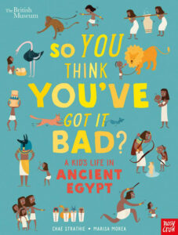  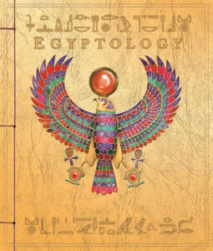  Properties and changes of materials  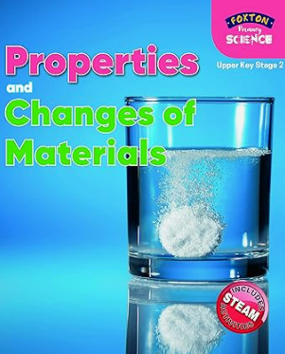 | The Northern Hemisphere  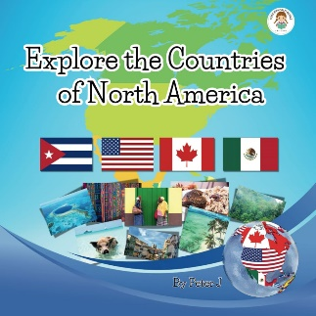  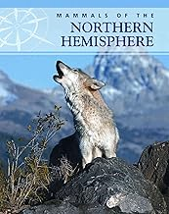 | Ancient Greeks  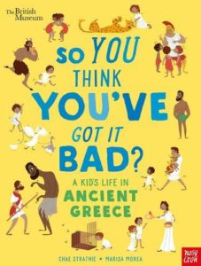  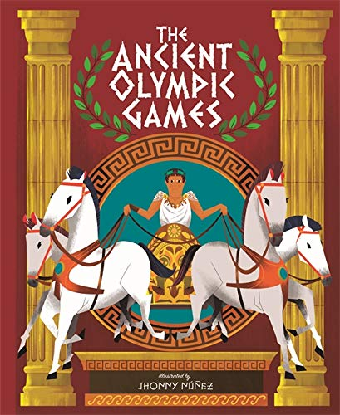  Forces  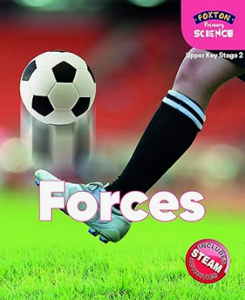 | North America – Earthquakes and Volcanoes  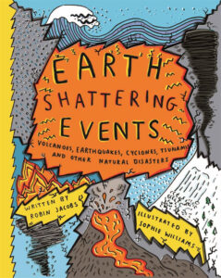  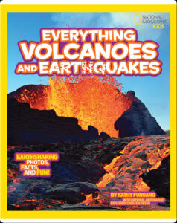  Earth and Space  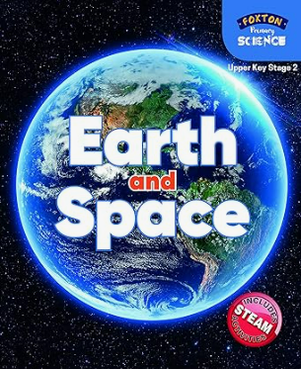 | Mayan Study  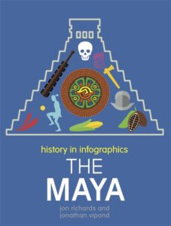  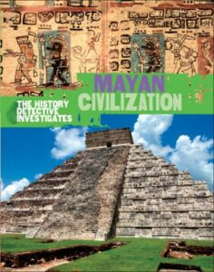  Animals including humans  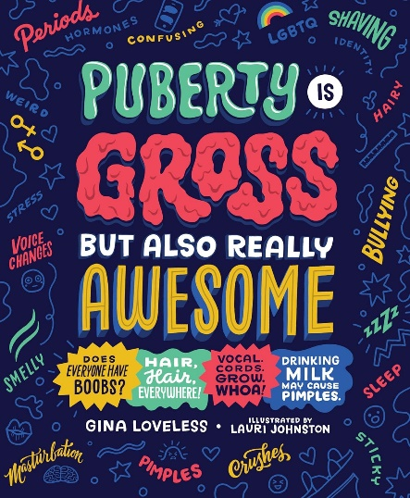 | North American Trade  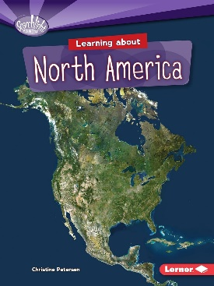  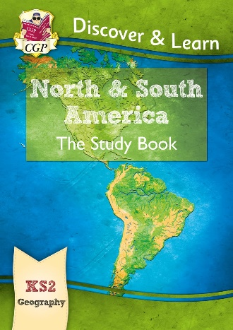  Living things and their habitats  