 |  | Autumn 1 | Autumn 2 |  | Spring 1 |  |  | Spring 2 |  | Summer 1 |  | Summer 2
Topics | History  Geography  Science | Toys in the past |  | Bingham  Everyday materials |  | Homes in the past  Plants | Directions |  | Queens of England |  | Where is Bingham in the UK?  Animals including humans
Reading for Pleasure stories |  | Rhyming books  Oi Dog  Polar bear, polar bear, what do you hear?  There’s a bear on my chair  Chocolate moose for greedy goose  Don’t put your finger in the jelly, nelly! |  | Julia Donaldson – Author study  The Gruffalo’s child  Zog  Snail and the whale  The Gruffalo  The paper dolls |  | Heroes and Villains  The giggle pigs  The Three Little Super Pigs  Goldilocks and Just One Bear | Traditional Tales  The ugly duckling  Princess and the pea  The elves and the shoemaker  Hansel and Gretel  Chicken licken |  | Poetry  Bananas in my Ears  The Lost Words |  | Animals  Where the wild things are  The tiger who came to tea  Elmer  Zerrafa Geraffa  Shark in the dark
Key texts/writing stimulus |  | Peace at last  - Jill Murphy  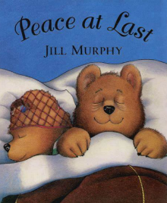  How to babysit a grandma  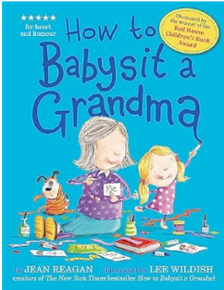  Shh we have a plan!  - Chris Haughton  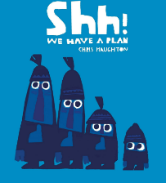 | Beegu  - Alexis Deacon  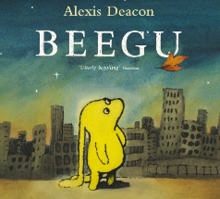  Dear Father Christmas  - Alan Durrant  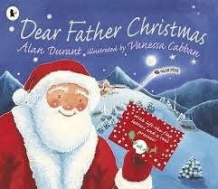  Mog’s Christmas Calamity – Visual Literacy  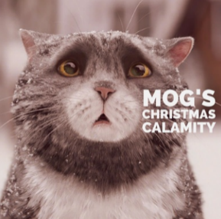 |  | Toys in Space  - Mini Grey  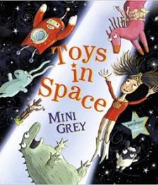  Stanley’s Stick  - John Hegley  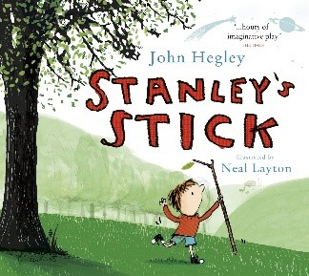  Stick Man  - Julia Donaldson  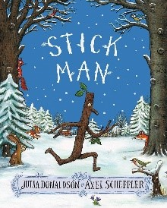 |  |  | Goldilocks and the three bears  - Susanna Davidson  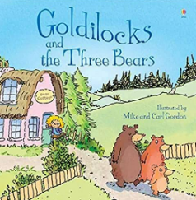  Growing a sunflower  - Practical |  | Whatever next – Jill Murphy  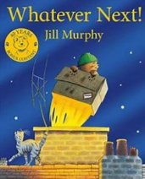  The Storm Whale by Benji Davies  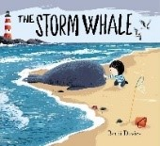  Little People, Big Dreams – Elizabeth II  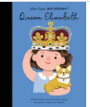 |  | Field Trip to Whisby Nature Education Centre  - Practical  The Bug Collector  - Alex Griffiths  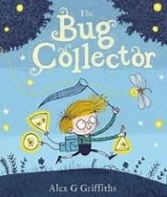  Fruit Salad  - Practical  The Sound Collector  - Roger McGough
Writing outcomes | Fiction  Non Fiction  Poetry | Narrative with a clear sequence  - Peace at last  Instructions  - How to babysit a grandma  List poem | Story mapping  - Beegu  Letter Writing  To Santa Claus in the first person  Adapted Narrative/Sequel – Creative writing of another occasion. Mog the hero - Mog goes on to save the day.  - Mog’s Christmas Calamity. |  | Lost toy poster  - Toys in Space  Story retell  - Stanley’s Stick  Postcard  - Stick Man  Rhyming poem  - Stick Man |  |  | Narrative – retell a traditional tale in a zigzag storybook (traditional tale)  - Goldilocks and the three bears  Letter of apology (Quick write)  - Note for Bears from Goldilocks  Non-chronological report (leaflet) – plants  - Sunflower Growing |  | Instructions  – What to take to the moon  Whatever Next!  Short narrative  - Storm whale  Fact File Leaflet  - Elizabeth II |  | First person Recount  - Year 1 Trip to Whisby Nature Education Centre  Narrative in the third person  - Bug collector  Instructions writing/recipes  - Fruit Salad  Poetry  The Sound Collector  - Roger McGough
Stages of Writing | - Engage with a stimulus - Examine real life and model texts of that genre - Learn the features of and language type of the genre - Practice the composite aspects of the text (such as intro, middle, conclusion) - Plan effectively - Complete and extended piece of writing drawing on modelling and real-life examples - Edit the writing based on previous learning and feedback - Publish a final piece
Ongoing writing objectives throughout year |  | Ongoing objectives across the year:  Write sentences:  - saying out loud what they are going to write about  Discuss what they have written with others  Read aloud their writing  Pupils’ vocabulary should be developed when they listen to books read aloud and when they discuss what they have heard. Such vocabulary can also feed into their writing. (NC Reading non-statutory)
Composition |  | - Continue to orally compose and sequence sentences before writing  - Begin to sequence sentences to form short written narratives  - Leave spaces between words  - Re-read what they have written to check that it makes sense  - Read aloud their writing to some of their peers  - Continue to discuss what they have written with the teacher or other pupils | - Continue to focus on speaking coherently and developing the use of complete sentences when verbally communicating thoughts and ideas  - Continue to orally compose and sequence sentences before writing  - Sequence sentences to form short narratives  - Sequence sentences to share information  - Create opportunities to discuss and read aloud their writing with peers and teacher  - Continue to focus on leaving spaces between words  - Use regular plural noun suffixes –s in writing  - Re-reading what they have written to check that it makes sense |  | - Continue to orally compose and sequence sentences before writing  - Begin to sequence sentences to form short written narratives  - Leave spaces between words  - Re-read what they have written to check that it makes sense  - Read aloud their writing to some of their peers  - Continue to discuss what they have written with the teacher or other pupils |  |  | - Continue to focus on speaking coherently and developing the use of complete sentences when verbally communicating thoughts and ideas  - Continue to orally compose and sequence sentences before writing  - Sequence sentences to form short narratives  - Sequence sentences to share information  - Create opportunities to discuss and read aloud their writing with peers and teacher  - Continue to focus on leaving spaces between words  - Use regular plural noun suffixes –s in writing  - Re-reading what they have written to check that it makes sense |  | - Say what they are going to write about  - Discuss and select new vocabulary for writing  - Continue to orally compose and sequence sentences before writing  - Continue to focus on use of complete sentences when verbally communicating thoughts and ideas with others (speaking coherently)  - Sequence sentences to form short narratives and recount narratives of an imaginary event  - Continue to embed re-reading what they have written to check that it makes sense and is coherently sequenced  - Ensure opportunities to read aloud their writing with their peers and the teacher |  | - Continue to embed orally composing and sequence sentences before writing  - Consolidate coherent sequencing of simple sentences  - Embed re-reading what they have written to check that it makes sense and is coherently sequenced  - Provide opportunity to read aloud their writing with their peers and teacher
Grammar and punctuation |  | - Practise punctuating sentences using capital letters and full stops to demarcate sentences  - Begin to use ‘and’ to join words  - Continue to develop the use of complete sentences when verbally communicating thoughts and ideas with others (speaking coherently)  - Begin to use regular plural noun suffixes –s in writing  - Recognise suffixes that can be added to verbs when no change is needed (ed, ing, er) | - Continue to use ‘and’ to join words  - Begin to use ‘and’ to join clauses  - Introduce questions marks to demarcate question sentences  - Continue to practise punctuating sentences with both capital letters and full stops to demarcate sentences  - Consistently use a capital letter for names of people  - Use a capital letter for the days of the week, and the personal pronoun ‘I’  - Use a capital letter for names of people and the days of the week |  | - Practise punctuating sentences using capital letters and full stops to demarcate sentences  - Begin to use ‘and’ to join words  - Continue to develop the use of complete sentences when verbally communicating thoughts and ideas with others (speaking coherently)  - Begin to use regular plural noun suffixes –s in writing  - Recognise suffixes that can be added to verbs when no change is needed (ed, ing, er) |  |  | - Continue to use ‘and’ to join words  - Begin to use ‘and’ to join clauses  - Introduce questions marks to demarcate question sentences  - Continue to practise punctuating sentences with both capital letters and full stops to demarcate sentences  - Consistently use a capital letter for names of people  - Use a capital letter for the days of the week, and the personal pronoun ‘I’  - Use a capital letter for names of people and the days of the week |  | - Begin to use regular plural noun suffixes –es in writing  - Continue to demarcate sentences with capital letters, full stops, question marks  - Further embed use ‘and’ to join clauses  - Introduce exclamation marks to demarcate sentences and phrases  - Use a capital letter for the names of places  - Develop range of adjectives used in spoken language to describe the characters  - Continue to leave spaces between words |  | - Develop use of varied sentence structure when sequencing to include simple and compound using ‘and’  - Use regular plural noun suffixes s/es in writing  - Identify and use suffixes that can be added to verbs when no change is needed  - Continue to recognise and begin to use how the prefix –un changes the meaning of verbs and adjectives  - Consolidate sentence demarcation learned across Year 1, including consistently using a capital letter for proper nouns, names of people and the personal pronoun ‘I’
Wider Curriculum |  | Toys in the Past  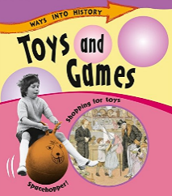  Toys and games – History snapshots  - Sarah Ridley  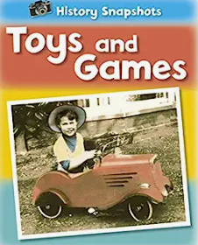 | Everyday Materials  Everyday materials (ways into science)  - Peter riley  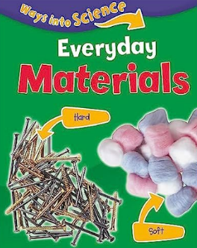 |  | Homes in the Past  Homes – History Snapshots  - Sarah Ridley  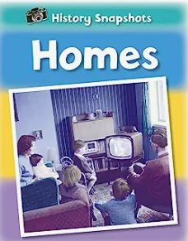  Plants  The Big book of blooms  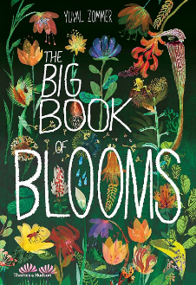 |  |  | Plants  Plants – National geographic kids  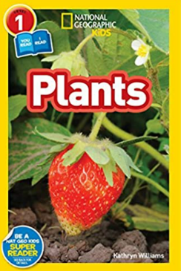 |  | Queens of England  Queen Victoria  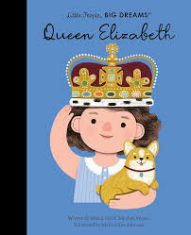 |  | Animals Including Humans  First book of animals  - Nicola Davis  