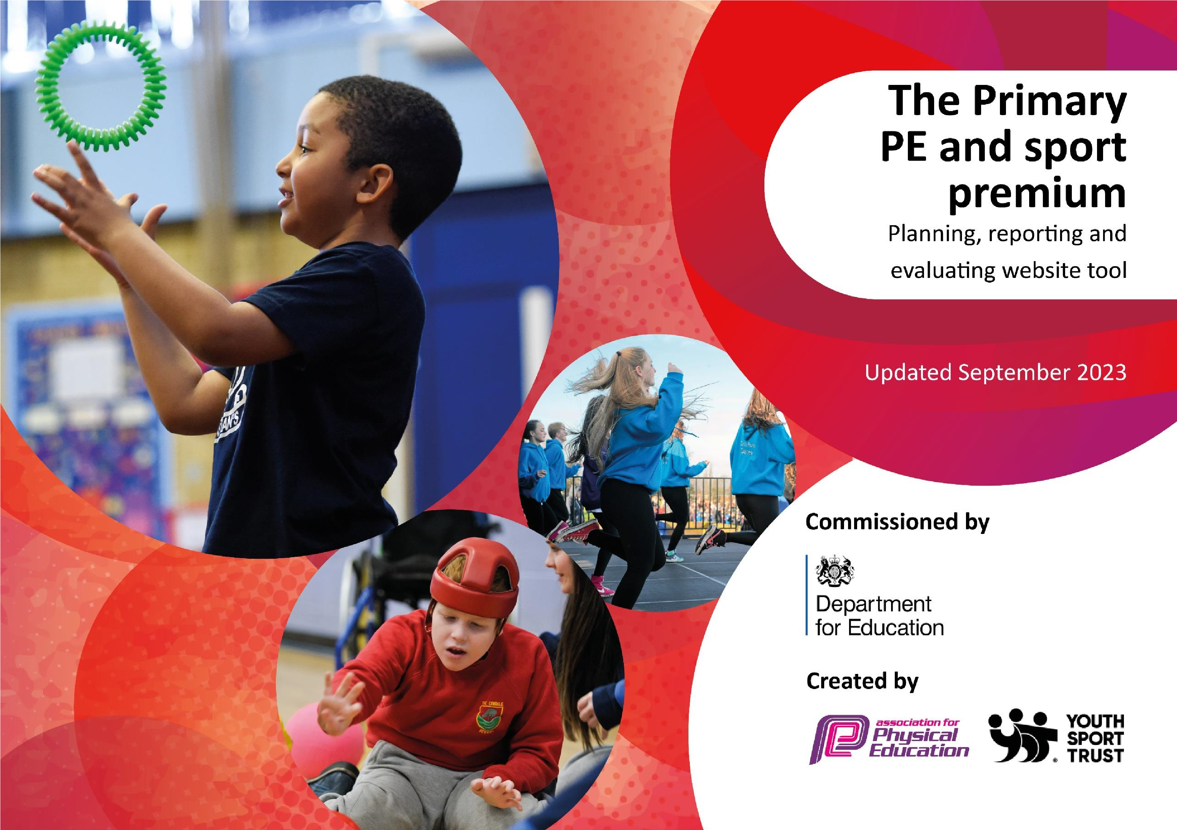

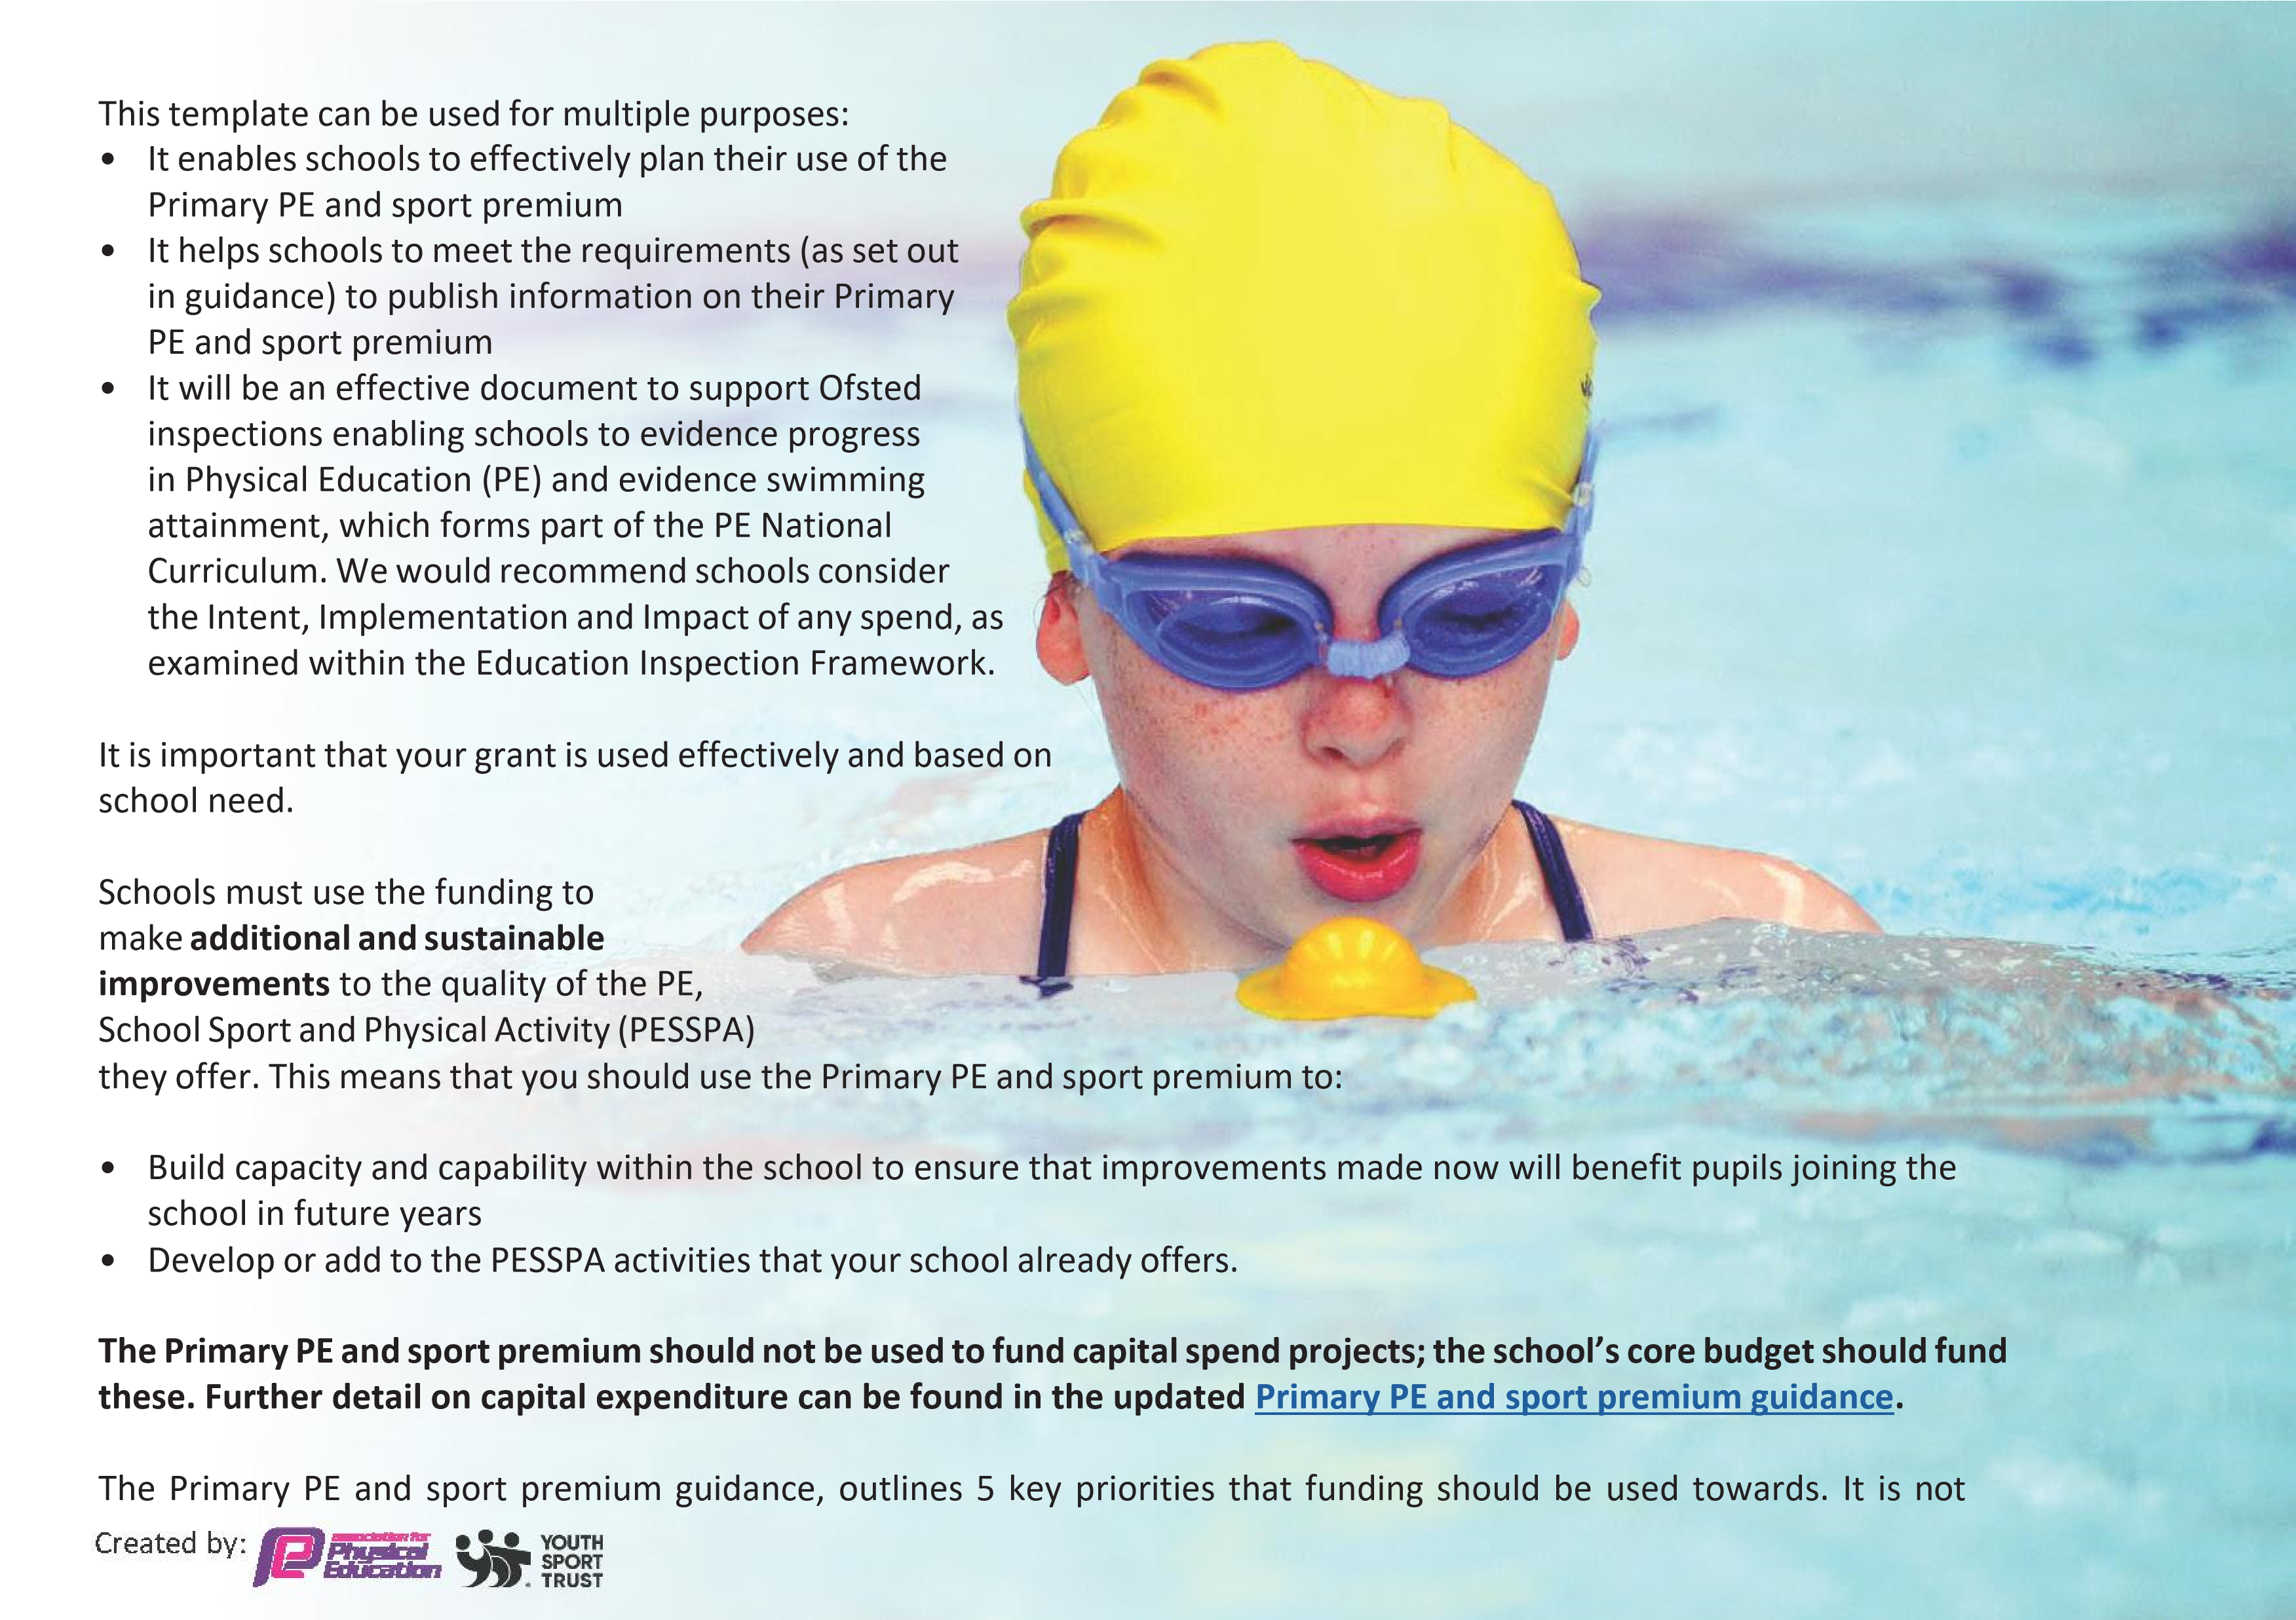
necessary that spending has to meet all the key priorities, you should select the priorities that you aim to use any funding towards.

Although completing this template is not a requirement for schools, schools are required to publish details of how they spend this funding. Schools must also outline what the impact this funding has had on pupils’ PE and sport participation and attainment and how any spending will be sustainable in the future. All funding must be spent by 31st July 2024.

The Department for Education has worked closely with the Association for Physical Education (afPE) and the Youth Sport Trust (YST) to develop this template and encourages schools to use it. This template is an effective way of meeting the reporting requirements of the Primary PE and sport premium.

Review of last year’s spend and key achievements (2022/2023)
We recommend you start by reflecting on the impact of current provision and reviewing your previous spend.

Activity/Action | Impact | Comments
To increase pupil participation and engagement in physical activity at lunchtimes.  To increase pupil participation and engagement in extracurricular sporting clubs. | - Inspire + Coach and Sports Apprentice Ambassadors trained Year 5 pupils to be playground leaders.  - A timetable created so that pupils knew what playground games to do and equipment needed.  - Sports Apprentice supported at lunchtime club (target areas – inactive/least active pupils)  - Training for Midday Supervisors as to supervise  activities  - Offered clubs which encourage physical activity or sport – netball, football, hockey, multiskills, etc. Monitor uptake of extra-curricular clubs. Pupil voice gained for clubs they would like on offer. Parental engagement encouraged and participation in running/supporting clubs.
Created by: 

Pupils to know physical activity improves cognitive function of the brain to help improve concentration to improve retention and recall.  Children will have a broader experience, they will try new sports coached by professionals within that specific sport. This will increase their knowledge of a variety of sports  Olympic Ambassador visits to promote a love of Sport and Physical activity across the school.  Staff will be clear on the roles and aims of PE at Bingham Primary School. All lessons will be good or outstanding delivering PE. PE sessions will enable pupils to develop leadership skills (using the leader logs). | •  •  •  •  • | Well-being days, Whole School Assemblies,  PSHE sessions, Active lessons, Curriculum PE,  Outside coaches and Inspire+ Ambassador visit Young Bronze Ambassadors to run assemblies about sport. This came through in pupil voice as children were able to about the importance of keeping fit.  Mini Olympics - A full day session for year 4 pupils exposing them to new activities and sports. Day was based around an Olympic opening ceremony, children enter the stadium representing a country with flag and banners. The children then took part in a variety of activities.  Johnathan Broom-Edwards who is a para-sport high jumper led a whole school assembly concentrating on the theme of perseverance. He talked to the children about working hard when faced with adversity.  Dai Greene, world Champion 400m hurdler delivered whole school assembly concentrating on the theme of perseverance. He talked to the children about working hard when faced with adversity.  Staff CPD has meant that staff feel confident to teach the PE curriculum at Bingham Primary School. All lessons watched were deemed to be at least Good. Assessments were completed to track pupils.
 | • | Audit of staff confidence in delivery of PE and physical activity curriculum was positive when compared to the start of the year.
Sports Apprentice employed through inspire + to support in the teaching of PE  Children to experience competitions and festivals with/against other local schools | •  • | PE lessons supported by Sports Apprentice has helped to strengthen lessons.  Year 3&4 and Year 5&6 football teams established to play against other schools.

Key priorities and Planning

This planning template will allow schools to accurately plan their spending.

Action – what are you planning to do | Who does this action impact? | Key indicator to meet | Impacts and how  sustainability will be achieved? | Cost linked to the action
To increase healthy active lifestyles amongst all children:  Encourage active play at lunchtimes.  Maintain clubs offer, whilst offering a diverse range of activities to take part in.  Ambassador visits for whole school | Year 6 children – playground leaders.  Children across the whole school.  All children. Staff within PE department and teachers to create plan for each half term, ensuring coverage for all. Staff to work additional hours after school to maintain offer.  Inspire+ to be used to encourage all children to be active  Sports Ambassador – via Inspire+ to provide assembly to whole school | Key indicator 2 -The engagement of all pupils in regular physical activity – the Chief Medical Officer guidelines recommend that all children and young people aged 5 to 18 engage in at least 60 minutes of physical activity per day, of which 30 minutes should be in school.  Key indicator 3: The profile of PESSPA  being raised across the school as a tool for  whole school improvement  Key indicator 4: Broader experience of a range of sports and activities offered to all pupils. | Children have been offered a variety of lunchtime activities this year through staff and playground leaders. By creating a timetable for these activities, this will continue into the next academic year, ensuring children are able to remain active during break and lunchtimes.  Children have received after school clubs supported by Inspire+. These have included – ParaSports, Cheerleading, OAA and gymnastics.  Ambassadors have led assemblies aiming to inspire and encourage children to lead active lifestyles. They have promoted a variety of sports, including athletics, swimming and parasports. This has broadened children’s knowledge of sports and will in time increase their motivations to try different activities. | £2000 for additional staff to lead after school clubs and lunchtime clubs  £400 for Inspire+ coach after school clubs  £800 for Inspire+  Ambassador
Promote leadership opportunities across the school:  - Playground  leaders  - Sports Council - Bronze Ambassadors  Provide children with more variety of sports and activities on offer:  - Increase sporting equipment – staff to do stock check each term, ensure the equipment matches the curriculum map and after school club offer.  Research new  activities - handball, dodgeball and  invest in equipment to provide additional opportunities.  Inspire+ coach to provide support with lunchtime offer – every Tuesday across the school.  - Mini Olympics  - Little Movers After School Club EYFS  Increase School  Competition  Participation;  - Liaise with other local primary schools to create fixtures in a variety of activities to allow more children to access.  Pupil rewards and recognition:  - Promotion of house games/ sports day through medals and trophies.  - Badges for participation in competitions ad festivals  - Medals for all for sports day  Increase Staff Knowledge:  - CPD for staff through courses and team teach  - Renew Getset4pe scheme of work  - Specialist PE Support | Year 6 children to apply for various roles across the school.  Training for roles to be provided by PE staff during lunchtimes.  PE Staff to stock check  All children across the school will have access to a wider variety of opportunities within curriculum and after school club.  Inspire+ coach to lead.  All children across will have access to the coach across the year.  Children will attend Mini Olympics arranged by Inspire+  Year 4 children to attend and experience a variety of different activities.  EYFS children  Inspire+ staff  Children across School will access virtual competitions – cross country, skipping, .  Through increase in fixtures arranged separately to the SGO buy in, will allow more children to access competitive sport.  All children will have the opportunity to earn a medal or badge during the school year.  Pe staff to ensure medals and badges are ordered and available as needed.  PE Staff will increase their knowledge of sports.  PE Lead to attend Conference accessing new initiatives and networking on new opportunities within the local area.  Children will have access to high quality provision, staff that have up  to date knowledge of new opportunities. High quality PE provision will be provided for all children.  PE Lead to work alongside specialist PE Lead via Inspire+ to work on upskilling staff, supporting apprentice, monitoring and evaluating delivery to ensure high quality PE for all pupils | Key indicator 3: The profile of PESSPA  being raised across the school as a tool for whole school improvement  Key indicator 4: Broader experience of a range of sports and activities offered to all pupils.  Key indicator 2 -The engagement of all pupils in regular physical activity – the Chief Medical Officer guidelines recommend that all children and young people aged 5 to 18 engage in at least 60 minutes of physical activity per day, of which 30 minutes should be in school  Key indicator 5: Increased participation in competitive sport.  Key indicator 3: The profile of PESSPA  being raised across the school as a tool for  whole school improvement  Key Indicator 1: Increased confidence, knowledge, and skills of all staff in teaching PE and sport. | Playground leaders have created a rich and inviting activity offer for lunchtimes. This will lead into next academic year, continuing the offer with a wider variety of activities for all.  Bronze Ambassadors and the Sports Council have led assemblies on Olympic Games and have worked hard throughout the year in supporting active lifestyles across the whole school community.  Equipment has been sourced in order to support and maintain the curriculum offer.  Lunchtime activities were supported y Inspire+ coach during Term 1 & 2. This allowed children to engage in activities to keep them active during breaktimes. This then continued throughout the academic year through playground leaders, staff and Bronze Ambassadors.  Children in Year 4 attended the Mini Olympics, taking part in a variety of sports including boccia, freestyle football, athletics and also learned a dance with the Royal Opera House. This broadened their knowledge of different activities.  Children in reception accessed a specialist after school club, aimed at promoting fundamental movement skills.  Children have take part in rounders fixtures during the summer term.  Through purchasing medals children have been rewarded for taking part in activities, This has promoted the profile of PESSPA across the school and has encouraged children to take part in activities they ay not normally have access to. This will be maintained next year, following the success of awards his year.  Through the employment of a Sports Apprentice, the provision for PE has improved significantly across school. Staff have worked alongside the apprentice in delivering PE lessons, working with geset4pe scheme. The apprentice has led lunchtime, after school clubs and supported at various events throughout the academic year, providing children with new and exciting opportunities.  Renewing getset4pe has allowed staff to create a broad curriculum map, ensuring knowledge is built and retained over time. Assessment is now embedded, with staff using the tools each half term to report on children’s learning.  Through the use of a specialist PE Lead, staff have been provided with support in a variety of areas. This has resulted in a broader spread of sports within the curriculum map, assessment to ensure knowledge over time has improved and monitoring of high quality PE is now in place. This will continue into the next academic year, ensuing high quality PE for all children across the school. | £500 for equipment and staff release to attend training alongside children.  £300 Inspire+ Bronze Ambassador Training sessions/equipment/ support throughout the year.  £1000 for equipment  £1000 for Inspire+ staff  (lunchtime clubs)  £800 for Mini Olympics  £500 for Inspire+ staff  (Little Movers)  £100 transport for Mini Olympics  £500 for staff to attend after school fixtures  £100 for transport to fixtures  £250 for rewards/ medals/ badges/ trophies  £10000 for Sports Apprentice  £200 for Conference  £330 for Getset4pe renewal  £1000 for Specialist PE support
Created by:

Key achievements 2023-2024

This template will be completed at the end of the academic year and will showcase the key achievements schools have made with their Primary PE and sport premium spending.

Activity/Action | Impact | Comments
Encourage active play at lunchtimes.  Maintain clubs offer, whilst offering a diverse range of activities to take part in.  Ambassador visits for whole school  Playground leaders, Sports Council and Bronze Ambassadors  Increase sporting equipment  Inspire+ coach to provide support with lunchtime offer – every Tuesday across the school.  Children attend Mini Olympics  Little Moves EYFS After School Club  Promotion of house games/ sports day through medals and trophies.  Employment of a Sports Apprentice  Renewal of geste4pe  Specialist PE Support | Children have been offered a variety of lunchtime activities this year through staff and playground leaders. By creating a timetable for these activities, this will continue into the next academic year, ensuring children are able to remain active during break and lunchtimes.  Children have received after school clubs supported by Inspire+. These have included – ParaSports, Cheerleading, OAA and gymnastics.  Ambassadors have led assemblies aiming to inspire and encourage children to lead active lifestyles. They have promoted a variety of sports, including athletics, swimming and parasports. This has broadened children’s knowledge of sports and will in time increase their motivations to try different activities.  Playground leaders have created a rich and inviting activity offer for lunchtimes. This will lead into next academic year, continuing the offer with a wider variety of activities for all.  Bronze Ambassadors and the Sports Council have led assemblies on Olympic Games and have worked hard throughout the year in supporting active lifestyles across the whole school community.  Equipment has been sourced in order to support and maintain the curriculum offer.  Lunchtime activities were supported y Inspire+ coach during Term 1 & 2. This allowed children to engage in activities to keep them active during breaktimes. This then continued throughout the academic year through playground leaders, staff and Bronze Ambassadors.  Children in Year 4 attended the Mini Olympics, taking part in a variety of sports including boccia, freestyle football, athletics and also learned a dance with the Royal Opera House. This broadened their knowledge of different activities.  Children in reception accessed a specialist after school club, aimed at promoting fundamental movement skills.  Through purchasing medals children have been rewarded for taking part in activities, This has promoted the profile of PESSPA across the school and has encouraged children to take part in activities they ay not normally have access to. This will be maintained next year, following the success of awards his year.  Through the employment of a Sports Apprentice, the provision for PE has improved significantly across school. Staff have worked alongside the apprentice in delivering PE lessons, working with geset4pe scheme. The apprentice has led lunchtime, after school clubs and supported at various events throughout the academic year, providing children with new and exciting opportunities.  Renewing getset4pe has allowed staff to create a broad curriculum map, ensuring knowledge is built and retained over time. Assessment is now embedded, with staff using the tools each half term to report on children’s learning.  Through the use of a specialist PE Lead, staff have been provided with support in a variety of areas. This has resulted in a broader spread of sports within the curriculum map, assessment to ensure knowledge over time has improved and monitoring of high quality PE is now in place. This will continue into the next academic year, ensuing high quality PE for all children across the school.

Swimming Data

Meeting National Curriculum requirements for swimming and water safety.
Priority should always be given to ensuring that pupils can perform safe self-rescue even if they do not fully meet the first two requirements of the National Curriculum programme of study

Question | Stats: | Further context  Relative to local challenges
What percentage of your current Year 6 cohort can swim competently, confidently and proficiently over a distance of at least 25 metres? | 8 out of 15 pupils were able to swim 25metres. 53% | Pupils only had half a term- 6 lessons to be able to achieve this as there weren’t any other sessions available.
What percentage of your current Year 6 cohort can use a range of strokes effectively [for example, front crawl, backstroke, and breaststroke]? | 7 out of 15 pupils were able to swim using a range of strokes. 47% | Although 53% could swim 25metres, one less pupil was able to use all the strokes. Again, all pupils were taught in just 6 weeks.

What percentage of your current Year 6 cohort are able to perform safe self-rescue in different water-based situations? | 75% of pupils were able to perform safe self rescue. | 75% of pupils were able to perform safe self-rescue on a number of occasions.
If your schools swimming data is below national expectation, you can choose to use the Primary PE and sport premium to provide additional top-up sessions for those pupils that did not meet National Curriculum requirements after the completion of core lessons. Have you done this? | Yes/No | We will be applying for top up sessions for 2024-25.
Have you provided CPD to improve the knowledge and confidence of staff to be able to teach swimming and water safety? | Yes/No | Staff have watched the current swimming and water safety videos provided by the leisure centre.
Signed off by:

Head Teacher: | Sara Pask
Subject Leader or the individual responsible for the Primary PE and sport premium: | Sara Pask
Governor:
Date: | 01.07.24

